Wireless Zip Code Search

Purpose
This job aid is designed to demonstrate how to utilize VITA’s wireless zip code search when reviewing wireless carriers’ equipment and rate plans.

Overview
The wireless zip code search tool allows users to quickly find pricing for services and products from wireless carriers in the Commonwealth. Not all addresses can be serviced by every carrier. Below are instructions on how to use the tool.

Procedures
Wireless Zip Code Search

1. | Use your browser to go to: vita.virginina.gov
2. | Select Procurement from the menu bar  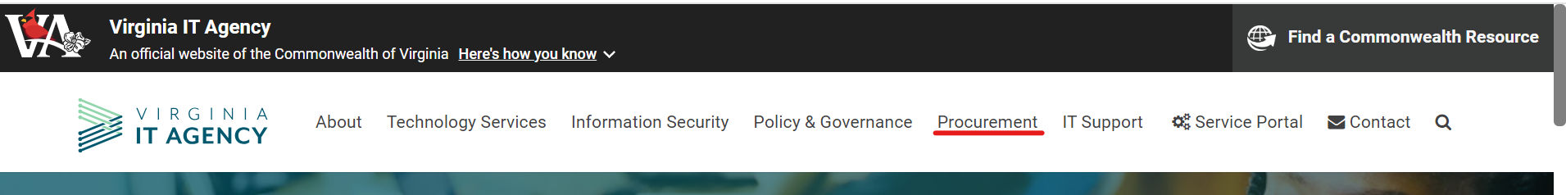

3. | Hover your mouse over Procurement and from the mega menu, under Contracts, select Wireless Zip Code Search. Double click to go to the landing page.  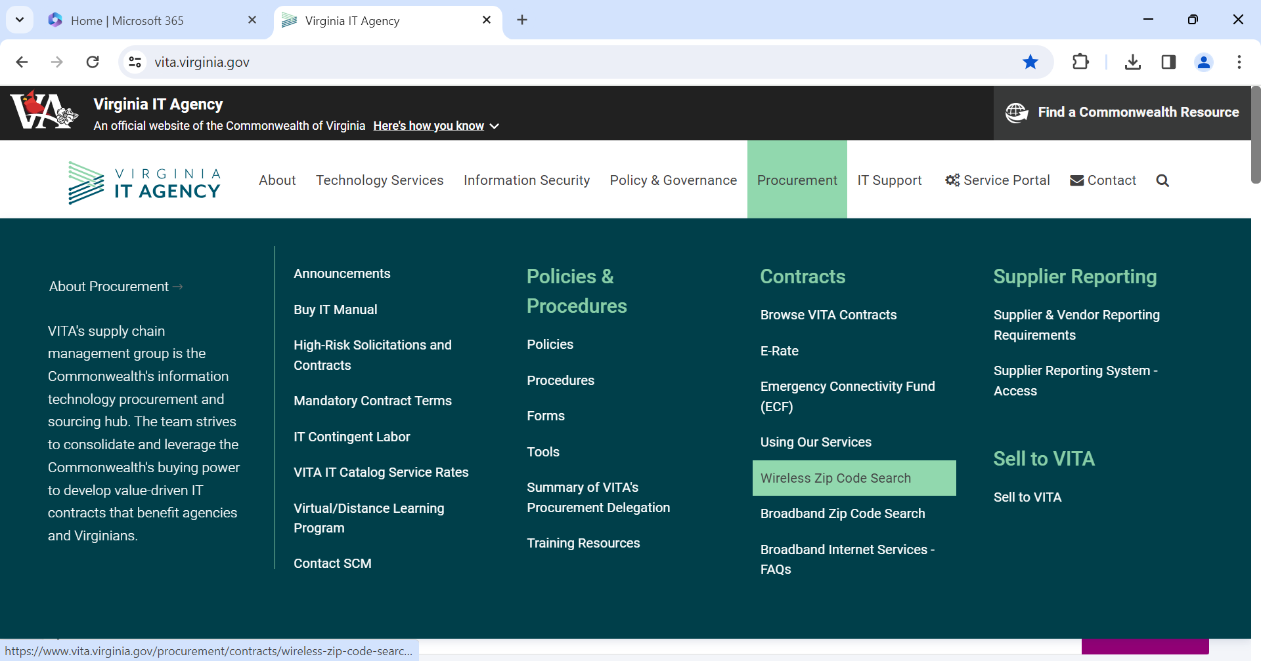
4. | From the Wireless Zip Code Search page, you can choose the specific carrier you wish to view the rate plan and product availability by clicking on the links provided under the header Cellular – Wireless (Distance learning rates are for schools and public safety and are available to agencies who provide public safety functions including first responder (fire and rescue), emergency response and disaster recovery.)  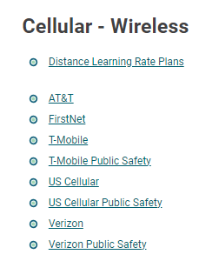
4. | After you select the carrier you wish to view, enter the zip code where the service is to be installed.  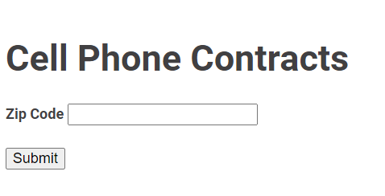
5. | The resulting page provides an overview of the specific cell phone contract for that wireless provider. The page will show plans available such as: PAY AS YOU GO; POOLED VOICE AND TEXT; SMARTPHONE VOICE, TEXT AND DATA; WIRELESS DATA; WIRELESS FIXED DATA; INTERNATIONAL; TABLET PLANS; any additional features and inclusions.
6. | The page also provides links to the current equipment price list.
7. | The page will show each plan and monthly contractual cost. It will show bundle options available for that service and the lowest price quoted. (This page now shows actual contract rates. Bills for services on this page will have additional fees, taxes or surcharges VITA is required to collect.)
8. | VITA wireless suppliers also provide Fixed Wireless which are considered broadband services. Note: These do not show in the Broadband Tool. Please consider when searching for a provider.

Questions?
Please contact VITA procurement: SCMInfo@vita.virginia.gov.

