COMMONWEALTH OF VIRGINIA

Information Technology Resource Management (ITRM)

Information Technology Investment Management Standard

Virginia Information Technologies Agency (VITA)

Reviews
- This publication was reviewed and approved by the Director of the Policy, Practice and Architecture Division.
- Online review was provided for agencies and other interested parties via the VITA Online Review and Comment Application (ORCA).
Publication Version Control
Questions related to this publication should be directed to the Manager of VITA’s Enterprise Architecture (EA) Division. PPA notifies Agency Information Technology Resources (AITRs) at all state agencies, institutions and other interested parties of proposed revisions to this document.
This following table contains a history of revisions to this publication.
Version | Date | Revision Description
COV ITRM Standard CPM 516-0O | 09/30/2008 | Publication of Information Technology Investment board (ITIB) approved original Standard
COV ITRM Standard CPM 516-01 | 05/09/2012 | This is a major revision to the Information Technology Investment Management (ITIM) standard which addresses administrative updates necessitated by changes in the Code of Virginia that impact the Commonwealth Project Governance Assessment (CPGA) methodology. Changes include revision of roles and responsibilities, increase in dollar values expenditures requiring CIO approval, clarification of requirements in section 4 and changes in the document’s format to align with the document development process.
COV ITRM Standard CPM 516-02 | 1/31/2017 | This is an extensive reorganization and rewriting of the ITIM standard and, consequently will not be identifying changes line-by-line. To do so would make the document difficult to read and understand. These changes are necessitated by changes in the Code of Virginia, updates to the Commonwealth Technology Business Plan and the Updated Commonwealth Strategic Plan for IT, and revisions to agency IT strategic planning requirements and processes. Additional changes to the standard include reorganization to improve flow and comprehension, revised figures, updated web links, refined definitions of investment risk and portfolio management, and inclusion of previous appendices in the body of the document. Further additions are a purpose statement at the beginning of each section and an appendix summarizing agency responsibilities.
COV ITRM Standard CPM 516-03 | 8/3/2021 | This is an administrative update to reflect changes to the Code of Virginia, and changes to the Commonwealth organizational structures that support ITIM decisions and approval processes. This update also includes updated web links and documentation references, including graphic references.  This document also contains font updates as per the ITRM Policy, Standard, Guideline and Formulation Standard, from Verdana to Rajdhani (headings) and Roboto (content) “Commonwealth” has also been capitalized throughout the document to reflect VITA communications policy.
Identifying Changes in This Document
- See the latest entry in the revision table above.
- Vertical lines in the left margin indicate the paragraph has changes or additions. Specific changes in word are noted using italics and underlines; with italics only indicating new/added language and italics that are underlined indicating language that has changed.
The following examples demonstrate how the reader may identify requirements and recommend practice updates and changes:
EXA-R-01 Example with No Change – The text is the same. The text is the same. The text is the same.
EXA-R-02 Example with Revision – The text is the same. A wording change, update or clarification is made in this text.
EXA-R-03 Example of New Text – This language is new.
EXA-R-03 Technology Standard Example of Deleted Standard – This standard was rescinded on mm/dd/yyyy.

Agency Exception Requests

Agencies that want to deviate from the requirements and/or technology standards specified in COV ITRM Standards may request an exception using the Enterprise Architecture Change/Exception Request Form. All exceptions must be approved prior to the agency pursuing procurements, deployments, or development activities related to technologies that are not compliant with the standard. The instructions for completing and submitting an exception request are contained in the current version of COV ITRM Enterprise Architecture Policy.

Agencies requiring deviation from the enterprise architecture (EA) EA225 requirements and/or technology standards, may request an exception using VITA's Archer application. Preface

Publication Designation
ITRM Standard EA516-03-02-03: Enterprise Architecture Standard
Subject
Information Technology Investment Management
Effective Date
January 31, 2017, October 1, 2021
Supersedes
COV ITRM Standard ITIM 516-02, January 31, 2017
Scheduled Review:
One (1) year from the effective date, then every two years thereafter.
Authority
Code of Virginia, §2.2-2007 (Powers of the CIO)
Code of Virginia § 2.2-2011. Additional powers Code of Virginia §2.2.26 Powers and duties of the ITAC relating to development, management, and operation of information technology

Scope
This standard is applicable to all Executive Branch state agencies and institutions of higher education (hereinafter collectively referred to as "agencies") that are responsible for the management, development, purchase and use of information technology resources in the Commonwealth of Virginia. This standard does not apply to research projects, research initiatives or instructional programs at public institutions of higher education.
Purpose
The purpose of this standard is to establish guiding principles for creating optimal business value from IT-enabled business investments at acceptable cost and risk.
General Responsibilities
Chief Information Officer of the Commonwealth (CIO)
Develops and recommends statewide technical and data policies, standards and guidelines for information technology and related systems.
Virginia Information Technologies Agency (VITA)
At the direction of the CIO, VITA leads efforts that draft, review and update technical and data policies, standards, and guidelines for information technology and related systems. VITA uses requirements in IT technical and data related policies and standards when establishing contracts; reviewing procurement requests, agency IT projects, budget requests and strategic plans; and when developing and managing IT related services
Information Technology Customer Advisory Council (ITAC)
The ITAC advises the CIO on the development, adoption and update of statewide technical and data policies, standards and guidelines for information technology and related systems.
Executive Branch Agencies
Provide input and review during the development, adoption and update of statewide technical and data policies, standards and guidelines for information technology and related systems.

Glossary
As appropriate, terms and definitions used in this document can be found in the COV ITRM IT Glossary. The COV ITRM IT Glossary may be referenced on the ITRM Policies, Standards and Guidelines web page at
https://www.vita.virginia.gov/policy--governance/glossary/

Table of Contents
1. INTRODUCTION 1
1.1 Intent 1
1.2 Organization of this Standard 1
2. IT INVESTMENT MANAGEMENT (ITIM) 2
2.1 Purpose 2
2.2 Description 2
2.3 IT Investments 2
2.4 Commonwealth Business Needs 4
2.5 The ITIM Methodology 5
2.6 Relation to Commonwealth IT Governance 6
3. STAKEHOLDERS 8
3.1 Purpose 8
3.2 Secretary of Administration 8
3.3 Commonwealth Chief Information Officer (CIO) 8
3.4 Information Technology Advisory Council (ITAC) 8
3.5 Commonwealth Secretariats 8
3.6 Commonwealth Agencies 9
3.7 Commonwealth Programs 9
3.8 IT Governance Groups 9
4. COMMONWEALTH IT STRATEGIC PLANNING 10
4.1 Purpose 10
4.2 Description 10
4.3 Commonwealth and Agency Technology Portfolios 12
5. MEASURING IT INVESTMENT VALUE 15
5.1 Purpose 15
5.2 What is Value? 15
5.3 Investment Risk 16
5.4 Using Value and Risk to Make IT Investment Decisions 16
6. ITIM PHASES AND ACTIVITIES 17
6.1 Purpose 17
6.2 Pre-Select Phase 17
6.3 Select Phase 19
7. PORTFOLIO MANAGEMENT PROCESS FOR ITIM 25
7.1 Purpose 25
7.2 Definition of Portfolio Management and Relation to the ITIM Activities 25
7.3 Commonwealth Project Portfolio Management Process 26
7.4 Capability and Technology Management Process 26
8. STAKEHOLDER RESPONSIBILITIES 28
8.1 Purpose 28
8.3 Commonwealth Chief Information Officer (CIO) 28
8.4 Information Technology Advisory Council (ITAC) 30
8.5 Commonwealth Project Management Division (PMD) 30
8.6 Commonwealth IT Investment Management Division (ITIMD) 31
8.7 Commonwealth Secretariats 32
8.8 Commonwealth Agencies 32
8.9 Commonwealth Programs 33
APPENDIX A – SUMMARY OF AGENCY RESPONSIBILITIES 35
APPENDIX B – LINKS TO RESOURCES 37

1. INTRODUCTION

1.1 Intent
The intent of the Information Technology Investment Management (ITIM) Standard is to establish a methodology for the identification, selection, management, and evaluation of information technology (IT) investments in order to maximize the business value of those investments to the Commonwealth. The ITIM methodology uses a lifecycle approach and portfolio management process to minimize risks and maximize the return on IT investments while supporting executive branch agency decisions to maintain, migrate, improve, retire, or initiate IT investments. The standard will define the ITIM methodology, describe the phases of the ITIM lifecycle, establish the basis for measuring the value of an IT investment, identify the required actions associated with each phase, position those actions within a portfolio management process, and assign roles and responsibilities for those actions. Since the Commonwealth and agency IT strategic planning process embodies the ITIM methodology, the standard also defines and describes related portions of that process.

1.2 Organization of this Standard
The ITIM methodology and lifecycle provide the organizational structure for this standard. The following sections describe the components of the methodology, the relation of ITIM to Commonwealth and agency IT strategic planning, and the use of portfolio management as the framework for executing ITIM activities. This standard also identifies the stakeholders and their responsibilities:

- IT Investment Management – describes the ITIM process and lifecycle, Commonwealth business needs, and relation to the IT governance process
- Stakeholders – identifies the stakeholders in the ITIM process
- Commonwealth IT Strategic Planning – describes the IT strategic planning process, Commonwealth Technology Portfolio, and their relation to the ITIM process
- Measuring IT Investment Value – defines the value of an IT investment
- ITIM Phases and Activities – identifies the four phases of the ITIM lifecycle and the activities associated with each phase
- ITIM Portfolio management – incorporates the activities into a portfolio management process that executes the ITIM methodology
- Stakeholder Responsibilities – states the stakeholder responsibilities in each of the four ITIM phases

2. IT INVESTMENT MANAGEMENT (ITIM)

2.1 Purpose
This section defines IT Investment Management, establishes that the business needs of agencies drive IT investments, presents the rationale for adopting ITIM to manage Commonwealth IT investments, and outlines the ITIM process and lifecycle.

2.2 Description
Information Technology Investment Management (ITIM) is a management process that provides for the pre-selection (identification), selection, control, and evaluation of business need driven Information Technology (IT) investments across the investment lifecycle. ITIM uses structured processes to minimize risks, maximize return on investments, and support Commonwealth agency decisions to maintain, migrate, improve, retire, or obtain IT investments. ITIM is the foundation for the Commonwealth’s approach to technology management as approved by the Commonwealth Chief Information Officer (Code of Virginia, § 2.2-2007).

2.3 IT Investments
IT investments are current (i.e., existing) or planned investments in IT that yield business value by enabling the Commonwealth and agencies to meet their business goals and objectives. The Code of Virginia defines Information Technology as “telecommunications, automated data processing, databases, the Internet, management information systems, and related information, equipment, goods, and services” (§ 2.2-2006). This standard interprets “management information systems” to include applications. In recognition of the emergence and adoption of new technologies, this standard extends the code definition to encompass IT services such as Software as a Service (SaaS) and cloud-based computing, IT environments such as social media, and IT related security.

Current IT investments are existing IT assets, defined by the Commonwealth IT Resource Management (ITRM) Glossary as “any software, data, hardware, administrative, physical, communications, or personnel resource”. Agencies’ existing IT assets formerly were documented in the Commonwealth Enterprise Technologies Repository (CETR); current IT assets now are documented in the application known as Archer, where agencies must maintain certification of their IT assets. Planned IT investments are projects, procurements, and VITA work orders/service requests that will result in the creation of new IT assets.

In this standard, IT assets are categorized as Infrastructure, Applications, or Services. Applications are further categorized as follows:
- Enterprise (systems of record, such as Cardinal, eVA)
- Collaborative (developed by VITA and agencies, such as the Enterprise Data Management (EDM) platform and Service Oriented Architecture (SOA)
- Agency specific (obtained and maintained by the agency)
Similarly, Services are categorized further by provider as VITA/IT Partnership or vendors.

IT investments that are projects or procurements are classified as Commonwealth IT investments if the investment’s total cost is equal to or greater than $250,000. IT investments less than $250,000 are classified as agency IT investments.

In addition, the Code of Virginia defines a “major” IT project as “any Commonwealth information technology project that has a total estimated cost of more than $1 million or that has been designated a major information technology project by the CIO (§ 2.2-2006). For the purpose of finance and budget reporting, Commonwealth IT projects or procurements whose cost is equal to $250,000 and less than $1 million are designated as “non-major” IT projects or procurements. IT investments proposed or underway are documented in the Commonwealth or agency technology portfolio (see section 4.3)

The IT investment categories are summarized below.
IT Investment Categories
- Existing Assets
  - Infrastructure
  - Applications
    - Enterprise
    - Collaborative
    - Agency specific
  - Services
    - VITA
    - Vendor
- Projects, procurements, and VITA work/service requests proposed or underway that will result in new assets
  - Commonwealth projects or procurements (>= $250K)
  - Agency projects or procurements (< $250K)

2.4 Commonwealth Business Needs
The business needs of agencies drive IT investments in the Commonwealth. To identify those business needs, agencies draw from numerous sources. The Governor of Virginia sets goals that provide overarching guidance and direction for how Commonwealth agencies will meet the Commonwealth's strategic objectives. These goals help focus the agencies on what the citizens need. The Commonwealth goals also form the foundation for both the Commonwealth Strategic Plan for IT and the agencies’ Strategic Plans. Federal and State mandates and laws also drive Commonwealth business needs.

There are also opportunities to provide citizen services that arise when grant funding is made available to the agencies. In addition, some agencies use Consumer Boards to identify the needs of the citizens who use the agency's services. Together, all of these drivers help Commonwealth agencies identify and document business needs, and invest in technology to meet those needs. Figure 1 illustrates the varied sources of business needs.

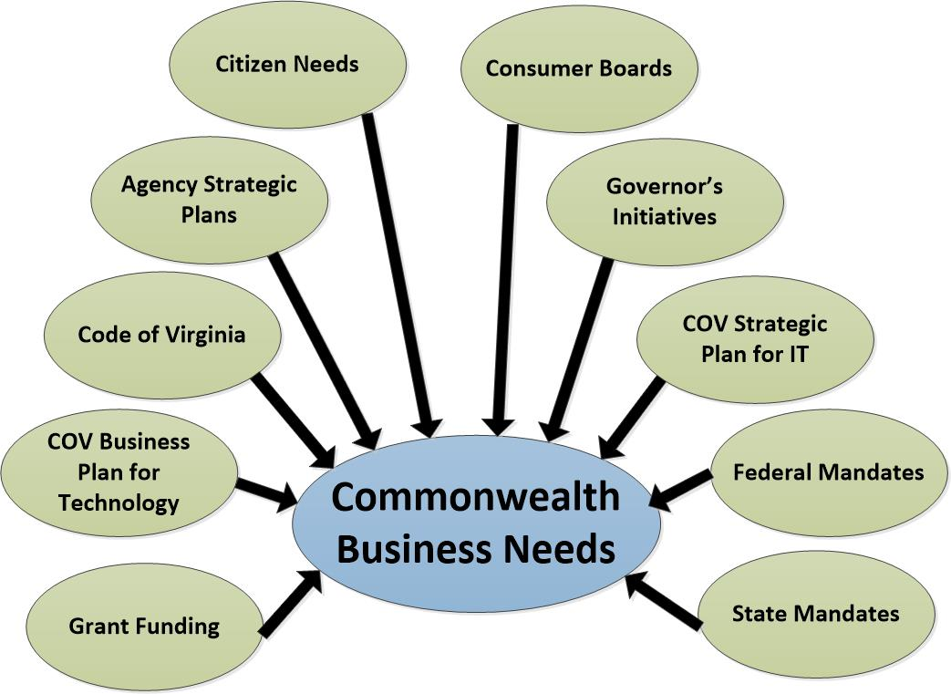

Figure 1: Sources of Commonwealth business needs

2.5 The ITIM Methodology
ITIM is the Commonwealth’s primary methodology for:
- Identifying the potential business value in proposed IT investments;
- Selecting IT investments that best meet the business needs;
- Monitoring the performance of the initiatives for developing and placing the selected IT investments into operation; and
- Determining if the selected IT investments are continuing to deliver the expected business value.

As shown in Figure 1, the ITIM lifecycle consists of four phases: Pre-Select, Select, Control, and Evaluate. The goal of the Pre-Select phase is to identify, analyze, and document potential IT investments that support agency business needs. The phase addresses the question “what proposed IT investments potentially solve business needs?” The goal of the Select phase is to decide from among the potential investments identified in the Pre-Select phase which investments to undertake. This phase answers the question “which IT investments best meet the business needs?” The goal of the Control phase is to ensure that IT investments are developed and placed in operation using a disciplined, well-managed, and consistent process. This phase speaks to the question “are the initiatives for developing and placing the selected IT investments into operation performing as planned?” Finally, the goal of the Evaluate phase is to compare the actual performance results and benefits of an investment to the target performance measures established for the investment. This phase targets the question “are the selected IT investments continuing to deliver the expected business value?”

The ITIM methodology is executed on a continuous basis as part of the Commonwealth and agency IT strategic planning process.

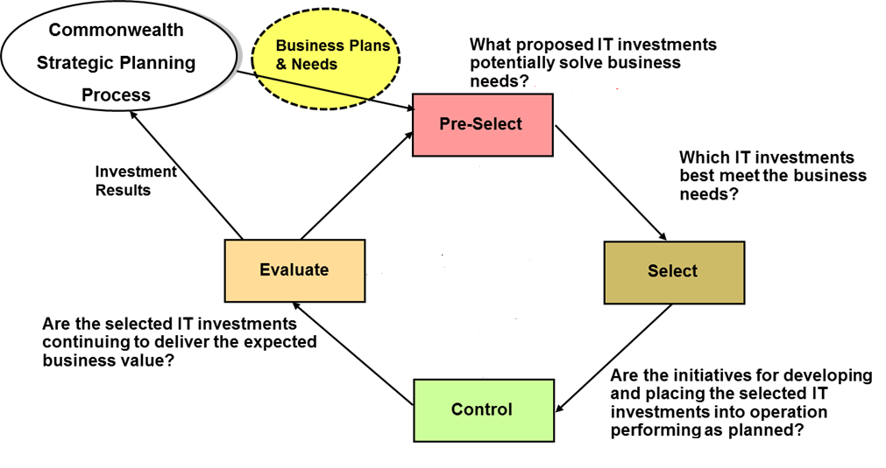

Figure 2: ITIM lifecycle phases and key questions addressed

ITIM in the Commonwealth is based on:
- The recognition that the Commonwealth strategic planning process drives technology investment strategies;
- The need to support effective communication about technology investment decisions;
- The concept that technology investments in the Commonwealth support and add value to the business of state government; and,
- The premise that technology investments should be prioritized, executed, and measured based on how they achieve agency strategic goals and objectives, and how they serve the critical business needs of the Commonwealth.

2.6 Relation to Commonwealth IT Governance
As the basis for the Commonwealth’s approach to managing IT investments, ITIM is the foundation for the broader Commonwealth IT enterprise governance framework. That framework establishes what types of IT investments can be made within the Commonwealth. The framework also directs how those investments should be managed to ensure they yield business value. The Code of Virginia (§ 2-2-2007) provides criteria for reviewing IT investments, while this standard establishes the processes for applying the criteria during the review cycle. Put another way, the Code of Virginia states the criteria and this standard describes the processes for implementing the criteria.

The four ITIM lifecycle phases provide a logical framework for review activities of the IT governance groups. ITIM documentation of potential and current IT investments, particularly in the Pre-Select phase, is a key input to the IT governance group review processes.

IT investments should be guided by the requirements and best practices established by the IT governance groups. Those groups and their primary governance activity are summarized below:

- Project Management Division (PMD)
  - Governs CIO approved Commonwealth projects and procurement governance requests.
- IT Investment Management Division (ITIMD)
  - Governs the Commonwealth and agency IT strategic planning process and investment business case evaluation.
- Commonwealth Security and Risk Management (Security)
  - Defines the security requirements that IT investments must meet.
- Enterprise Architecture (EA)
  - Manages the process that is focused on building and maintaining an enterprise-wide business, information, solutions and technical infrastructure and architecture.
  - Establishes Commonwealth data standards to which IT investments must adhere.
- Supply Chain Management (SCM)
  - Governs procurements associated with IT investments.

3. STAKEHOLDERS

3.1 Purpose
This section identifies the stakeholders who have responsibility for activities, decisions, or governance within the ITIM lifecycle and describes each stakeholder’s role.

3.2 Secretary of Administration
Commonwealth Technology Management is governed by the Secretary of Administration who sets technology strategy and reviews and prioritizes major technology investments proposed by Commonwealth executive branch agencies and institutions of higher education.

3.3 Commonwealth Chief Information Officer (CIO)
The Commonwealth Chief Information Officer (CIO), as established in the Code of Virginia (§2.2-2005), is appointed by the Governor, and leads the Virginia Information Technologies Agency (VITA.) On behalf of the Governor, the CIO manages a wide variety of technology activities. In particular, the CIO supports executive branch agency IT investment decisions during each phase in the ITIM lifecycle.

3.4 Information Technology Advisory Council (ITAC)
The Information Technology Advisory Council (ITAC) is an advisory council in the executive branch of state government responsible for advising the CIO on the planning, budgeting, acquiring, using, disposing, managing, and administering of information technology in the Commonwealth. The legislation that created the ITAC is codified in the Code of Virginia §2.2-2699.5 The ITAC offers options for assessing and meeting the Commonwealth’s business needs through the application of information technology.

3.5 Commonwealth Secretariats
Commonwealth Secretariats coordinate the activities of agencies in the Secretariat to ensure efficient, effective delivery of services. The Secretary, the leader of a Commonwealth Secretariat, is the principal advisor to the Governor on policy related to the services the Secretariat’s agencies provide. Through ITIM, the Commonwealth Secretariats support agency IT investment decisions by determining the overall business priorities for their Secretariat.

3.6 Commonwealth Agencies
Commonwealth agencies are defined as any agency, institution, board, bureau, commission, council, public institution of higher education, or instrumentality of state government in the executive department listed in the appropriation act. Agencies are the business owners of IT investments in the Commonwealth, and the key stakeholders in the ITIM lifecycle. All ITIM activities support Commonwealth agency IT investment decisions. Within agencies, the agency head and the Agency IT Resource (AITR) have specific roles in executing ITIM activities, as delineated in Section 8.

3.7 Commonwealth Programs
A program is a group of related projects managed in a coordinated way to obtain business value and control. Programs may include elements of related work outside of the scope of the discrete projects in the program. A program can be established in a variety of ways:
- By an agency to manage a group of projects collectively;
- By a Secretariat to manage a collection of projects that require collaboration across agency or Secretariat boundaries;
- By the Governor to facilitate enterprise-wide (i.e., state government-wide) productivity and technology improvements, shared services, or collaboration across Secretariat boundaries; or
- By the General Assembly.
Where the CIO has an interest or oversight responsibilities for the IT components of a program, PMD will provide oversight on behalf of the CIO.

3.8 IT Governance Groups
As noted in section 2.5, IT governance groups (PMD, ITIMD, Security, EA, CDG, and SCM) are responsible for ensuring that proposed and current IT investments conform to Code of Virginia and governance requirements. In addition to the activities stated in section 2.5, the groups periodically review existing IT investments. As a result of such a review, a governance group may identify an operational risk/issue (OR/I) that is documented and presented to an agency. The agency receiving an OR/I must respond with a remediation plan, which may include a Business Requirement for Technology entry in the agency or Commonwealth technology portfolio (see section 6.2.1.3).

4. COMMONWEALTH IT STRATEGIC PLANNING

4.1 Purpose
This Section describes the IT Strategic Planning process and relates the process to other Commonwealth strategic planning efforts. The section also establishes the Commonwealth Technology Portfolio (CTP) as the repository for technology investments and agency IT Strategic Plans for Executive Branch agencies.

4.2 Description
Commonwealth agency strategic plans, the Commonwealth Strategic Plan for Information Technology, and the Governor’s Priority Initiatives are used to ensure that IT investments directly and measurably support business goals. Both the Commonwealth strategic planning process and the ITIM process align with the Commonwealth budgeting cycle.

Agencies within the executive branch develop and implement strategic plans and budgets designed to support the achievement of Commonwealth long-term objectives and the fulfillment of agency missions and mandates. Strategic planning is a management tool used by agency leaders to determine and communicate what the agency wants to accomplish in the upcoming budget biennium, to provide guidance to all agency departments, to track the agency’s overall performance, and to make course corrections to help the agency achieve its strategic goals.

Updates to the Commonwealth and agency strategic plans occur in conjunction with key budget events; for example, the submission of the Governor’s budget to the General Assembly or the passage of the Appropriation Act. Ad hoc strategic planning updates are allowed during the year to support changing business priorities with agency head and Commonwealth CIO approvals.

In developing their IT Strategic Plans, agencies rely on several external sources of information as well as internal documentation. These sources and the agency IT Strategic Plan are described in the following sections.

4.2.1 Commonwealth Technology Business Plan
The Commonwealth Technology Business Plan is intended to be the link between the Commonwealth’s business priorities and the Commonwealth Strategic Plan for Information Technology, providing business guidance and direction to executive branch agencies’ collective technology initiatives. Please see Appendix B for link to resource document.

4.2.2 Commonwealth Strategic Plan for Information Technology
The Commonwealth Strategic Plan for Information Technology specifies the strategic Mission and Vision for information technology in the Commonwealth, and strategic goals for information technology, including objectives, measurements and initiatives that are intended to deliver on that Mission and Vision. The strategic goals align to and support the initiatives identified in the Commonwealth Technology Business Plan and the long-term business objectives identified in the Roadmap for Virginia's Future.

All Commonwealth agency strategic plans are expected to fully align with the strategic goals, objectives, measurements, and initiatives identified in the Commonwealth Strategic Plan for Information Technology. Please refer to Appendix B of this document for a link to the plan.
.

4.2.3 Commonwealth Enterprise Architecture
Commonwealth Enterprise Architecture (EA) is a fundamental factor in developing and monitoring strategic planning for information technology. To ensure that EA and information technology support the business of the Commonwealth, an EA process model has been adopted that continually integrates and synchronizes appropriate technologies so that they best serve the business of state government and the citizens of the Commonwealth. In this process model, business needs drive what is done in the Commonwealth and enterprise architecture determines how information technology supports those business needs. For more information about EA, please refer to Appendix B of this document for a link to the plan.

4.2.4 Enterprise Information Architecture
Enterprise Information Architecture (EIA) promotes the governance, asset management and sharing of the Commonwealth’s data assets. The Commonwealth Data Governance team is responsible for implementing EIA strategies under four domains: Data Governance, Data Asset Management, Data Standards, and Data Sharing. The Commonwealth Data Governance team operates within these domains through collaboration with data stewards, business leads, technical leads, security staff and other stakeholders across the enterprise. Information about the EIA and Commonwealth Data Governance team can be found in Appendix B of this document.

4.2.5 Agency IT Strategic Plan
The agency IT Strategic Plan (ITSP) is a collaborative effort between the business and IT leaders within the agency, and is comprised of the following sections: IT Summary, Agency Operational Risks/Issues, Agency Business Requirements for Technology, Active Portfolio, and IT Budget Estimation Tables. The ITSP is the primary tool for communicating how agency business needs drive IT investment decisions, and how the agency’s IT investments support the business goals and objectives of the agency and the Commonwealth. The ITSP provides a detailed view of agency IT investments, identifies the alignment of each individual IT investment to the agency’s service area objectives and “as-is” business architecture, and provides additional information for each investment (i.e., costs, start and end dates, service area owner, etc) A link to ITSP planning resources is available in Appendix B of this document.

4.3 Commonwealth and Agency Technology Portfolios
Commonwealth and agency technology portfolios are repositories for information on IT investments. The portfolios are central to the effective functioning of the ITIM methodology. A portfolio management approach to the ITIM life cycle is described in section 7.

4.3.1 Commonwealth Technology Portfolio
The Commonwealth Technology Portfolio (CTP) is the Executive Branch repository for technology investments planned or underway, and is an aggregated view of individual agency projects, procurements, and current operational environments supporting Commonwealth and agency business strategies. The CIO has established a Commonwealth IT portfolio management tool to assist stakeholders with planning, executing, and documenting all IT investments. The current tool is Planview Enterprise One, a full spectrum portfolio and work management solution that contains a Portfolio and Resource Management (PRM) component and a Capability and Technology Management (CTM) component. Figure 3illustrates the central role that CTP plays in the ITIM process.

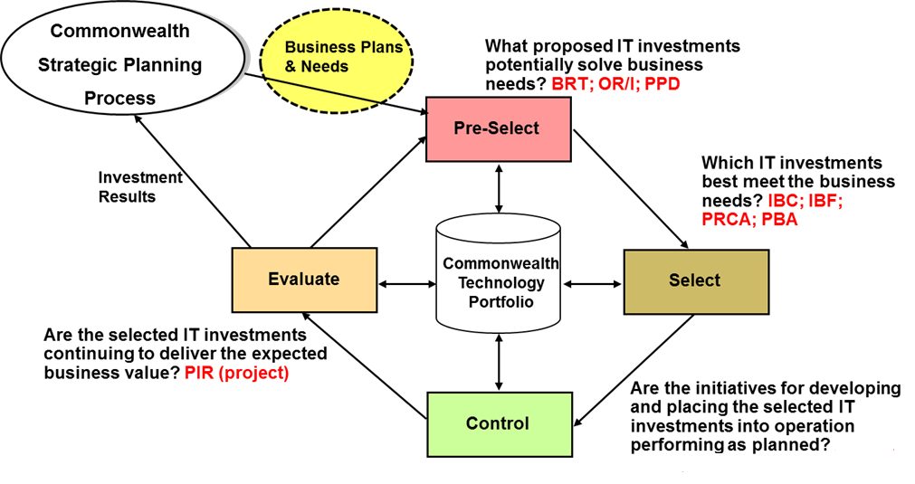
Legend:
BRT – Business Requirements for Technology
OR/I – Operational Risk/Issue
PPD – Project or Procurement Determination
IBC – Investment Business Case
IBF – Investment Biennium Funding
PRCA– Project Risk/Complexity Assessment (initial)
PBA – Procurement Business Alignment
PIR – Post Implementation Review (for projects)

Figure 3: ITIM lifecycle phases and key questions addressed.
4.3.2 Commonwealth Technology Portfolio (CTP): Planview Portfolio Resource Management (PRM) and Capability and Technology Management (CTM) Components
The Portfolio Resource Management (PRM) component in Planview is the repository for capturing and managing all Commonwealth investments: projects, procurements, and agency IT Strategic Plans. All projects and procurements equal to or greater than $250,000 as well as Executive Branch agency IT Strategic Plans are subject to Commonwealth oversight and governance and must reside in CTP.
The CTM component in Planview is the repository for cataloging and managing agency IT operational assets, including applications, data, and software tools used by executive branch agencies to support their businesses. Agency entries in Planview CTM must be kept accurate and up to date as changes occur. Certification of the data in the Planview CTM component is required as part of the agency IT strategic planning process.
4.3.3 Agency IT Portfolio
The Commonwealth Technology Portfolio (CTP) is a best practice of keeping a single repository for all the IT investment information the agency needs to manage. All of an agency’s asset and IT investment management information must be documented in CTP or as directed by oversight and governance.

5. MEASURING IT INVESTMENT VALUE

5.1 Purpose
This Section defines the value and risk of an IT investment, and describes the use of value and risk to make IT investment decisions.

5.2 What is Value?
Value is a measure that demonstrates how an IT investment contributes to improved constituent service levels, agency operational efficiencies, and the strategic goals of the Commonwealth. IT investments may have multiple value measures in one, two, or all three value categories. In turn, a value measure may apply to more than one category.

The Commonwealth uses the measurement of an IT investment’s value as a way to quantify agency business benefits and track them throughout the IT investment lifecycle. Measuring IT investment value with a focused, standardized set of evaluation criteria allows the Commonwealth to forecast value during investment business case development and investment selection.

5.2.1 Constituent Service
Constituent service is the measure of how well an IT investment helps the citizens of the Commonwealth. This can include offering financial benefits such as lower cost of interaction, reduced fees, or quicker reimbursements. It can also include service improvements such as reduced wait times, improved access, new services leading to constituent benefits, or a greater focus on constituent needs.

5.2.2 Operational Efficiency
Operational efficiency is the measure of an IT investment’s capability to reduce agency operational and inventory costs, or provide other financial benefits such as streamlined supply chains, new revenue streams, higher productivity, error reductions, faster merging of administrative processes, or an improvement in agency performance against agency performance measures.

5.2.3 Strategic Alignment
Strategic alignment is the measure of an IT investment’s support for Commonwealth goals and objectives as expressed in the individual agency strategic plans, the Commonwealth Strategic Plan for Information Technology, the Governor’s Initiatives, federal and state mandates, and the Commonwealth’s Enterprise Architecture. It also includes the applicability of the investment across the enterprise.

5.3 Investment Risk
Like value, risk is an inherent characteristic of an investment. The COV ITRM Glossary defines risk as an uncertain event or condition that, if it occurs, could have a positive or negative effect on an investment’s objectives. Several factors can contribute to investment risk, including the following:
- cost of the investment, either absolute or as a percent of the agency or secretariat budget
- source and stability of the investment funding
- complexity of the investment
- degree of investment stakeholder support
- degree of familiarity with the investment’s underlying technology
- importance of the investment to meeting Commonwealth or agency business objectives or mandates

Investment risk can arise in any of the ITIM phases.

5.4 Using Value and Risk to Make IT Investment Decisions
One of the primary goals of ITIM is to support value-based, risk-adjusted agency IT investment decisions, and the use of value and risk can be tracked across the entire ITIM cycle. In the Pre-select Phase, the value of a potential IT investment in serving an agency business need is compared to the IT investment’s risks. In the Select Phase, IT investments are ranked based on their proposed value relative to risk and the investments with the best ranking chosen for implementation. In the Control Phase, IT investment values are refined and risks are mitigated in conjunction with asset delivery. And in the Evaluate Phase, IT asset performance is measured against value metrics to determine if the investment is meeting the agency’s business needs.

6. ITIM PHASES AND ACTIVITIES

6.1 Purpose
This Section will define and describe the four phases of the ITIM lifecycle (pre-select, select, control, and evaluate) and establish the activities required in each phase. Execution of the lifecycle activities typically occurs annually as part of Commonwealth and agency strategic planning and budgeting processes. Figure 5 provides an overview of the details presented in this section, including the forms used to enter IT investment information into CTP.

Figure 3: ITIM phases and related CTP investment forms

Legend:
BRT – Business Requirements for Technology
OR/I – Operational Risk/Issue
PPD – Project or Procurement Determination
IBC – Investment Business Case
IBF – Investment Biennium Funding
PRCA– Project Risk/Complexity Assessment (initial)
PBA – Procurement Business Alignment
PIR – Post Implementation Review (for projects)

6.2 Pre-Select Phase
The purpose of the Pre-Select phase is to identify, analyze, and document potential IT investments that support agency business needs in the context of Commonwealth business needs. The Pre-Select phase allows agencies to define business objectives, associate costs with the potential IT investments needed to meet those business objectives, and document a range of performance measures for their potential IT investments.

Completion of the Pre-Select phase answers the question “What proposed IT investments potentially solve agency business needs?”

6.2.1 Pre-Select Phase Required Activities
Execution of the Pre-Select phase involves the following activities.

6.2.1.1 Identify Business Needs
A key outcome of the agency IT strategic planning process is the identification of new business needs that can be met with potential IT investments. The agency may identify additional IT investment opportunities from the Commonwealth Strategic Plan for Information Technology, the Commonwealth Technology Business Plan and the Governor’s Priority Initiatives.

6.2.1.2 Prioritize Business Needs
Agencies frequently will not have the resources to undertake all of the IT investment opportunities identified in their strategic plans, therefore, agencies must review and rank potential IT investments according to their business priorities. In determining business priorities, agencies may draw information from their Agency Strategic Plan, their Secretariat, and other appropriate mandates and directives.

6.2.1.3 Develop Business Requirements for Technology (BRT)
The initial step in documenting a business need is to enter a Business Requirement for Technology (BRT) in the Commonwealth or agency portfolio. The BRT enables agencies to identify and document unmet business needs before it can be determined what type of IT investment is required. BRT’s permit the Commonwealth or agency portfolio to separate identification of business needs from establishment of specific IT investments. Documentation of new and unmet business needs in the Commonwealth or agency IT portfolio enhances the role of the portfolio as the repository for all current or potential IT investments and provides visibility to all possible IT investments during the IT strategic planning process.

BRTs are subdivided into two types, requirements for new technology and requirements for existing technology. Business Requirements for New Technology (BRnT) document requirements that are new to the agency, such as implementing support for new business functions or adding new functionality to an existing application. In contrast, Business Requirements for Existing Technology (BReT) document requirements for supporting existing technology investments, such as application release upgrades or service contract renewals. Subdividing BRTs into two types simplifies documentation of each type of IT investment, since the information required to make informed investment decisions differs between the two types.

6.2.1.4 Respond to Operational Risk/Issues (OR/I)
A BRT also may be entered in the agency or Commonwealth portfolio in response to receiving an Operational Risk/Issue from one of the governance groups. For example, the Enterprise Architecture group may send an agency an OR/I informing the agency that that it is using a software version that is no longer supported. In response, the agency may generate a BReT documenting their intent to upgrade to the current software version.

6.2.1.5 Determine if Proposed IT Investments are Projects, Procurements, or Both

In addition to identifying and initially documenting a new or unmet business need, the BRT establishes a vehicle for recording further details of the business need and research on potential solutions, including an IT investment. If it appears that an IT investment will address the business need, the investment is ready for review and ranking in the select phase of the ITIM lifecycle. To facilitate that review, the final step in the Pre-select phase is to determine if the investment will take the form of a project, procurement, or both. The CTP has a process which leads to an initial determination.

6.3 Select Phase
The purpose of the Select Phase is to decide from among the potential IT investments identified in the Pre-Select Phase, and IT investments in the current Commonwealth and agency technology portfolios, which IT investments best support:
- The agency‘s mission, strategic goals, and mandates.
- The Commonwealth Strategic Plan for Information Technology.
- The Governor’s Priority Initiatives.

In the Select Phase, all current and proposed IT investments are analyzed and ranked by their business value, in conjunction with the Commonwealth budget development cycle, to determine which investments are to be initiated or continued. For proposed IT projects, an Investment Business Case (IBC) is prepared. For proposed IT procurements, a Procurement Business Alignment (PBA) is prepared. The IBC and PBA for proposed IT investments are initially evaluated and scored by the agency. The scores from the proposed IT investments are then analyzed along with the scores from the agency’s on-going IT investments. Based on the agency internal analysis, the agency ranks all its IT investments and subsequently selects the IT investments to include or retain in the Agency IT portfolio and by reference in their IT Strategic Plan. Once the agency selects its IT investments, proposed investments that qualify as Commonwealth investments are submitted for evaluation and approval at the Commonwealth level.

Completion of the Select Phase answers the question “What IT investments best meet the business needs?”

6.3.1 Select Phase Required Activities
Execution of the Select phase involves the following activities.

6.3.1.1 Develop and Approve Proposed IT Investments
After proposed IT investments are identified based on business needs and documented in BRTs, initial project or procurement documentation is prepared. For agency IT investments, this documentation is developed according to established agency procedures, which follow best practices as documented in the Commonwealth project management policies, standards, and guidelines. For Commonwealth IT projects or procurements, documentation is developed in CTP building on the previously entered BRTs. For IT projects, this documentation includes the Investment Business Case (IBC) and the initial Project Risk/Complexity Assessment (PRCA). For IT procurements, a Procurement Business Alignment (PBA) is prepared. Additional documentation for either includes Investment Biennium Funding (IBF) covering the appropriate funding period(s). For Commonwealth procurements, the PBA is reviewed by the governance groups and approved by the CIO.

For proposed Commonwealth IT projects, the IBC is evaluated and scored based on established Commonwealth criteria. At the agency level, it is highly recommended that the agencies use the Commonwealth’s evaluation and scoring criteria, as established by the CIO. The results of the agency evaluation and scoring activities should be documented in the agency portfolio tool.

Commonwealth IBCs must be evaluated and approved by the CIO prior to inclusion in CTP. ITIMD administers the evaluation and approval process using the Commonwealth IT portfolio management tool workflow. The final output from this evaluation and approval process is a decision on whether a proposed investment is either granted Investment Business Case Approval (IBC), a project portfolio category for projects that have received approval of the project’s investment business case from the CIO. IBC approval authorizes the agency to expend funds in preparation for obtaining project initiation approval.

For proposed IT procurements, the PBA is reviewed by the CIO if the value is equal to or greater than $250,000.

6.3.1.2 Analyze and Rank Investments
The next requirement in the Select Phase is to analyze all the approved IT investments in the portfolio and rank them in order by business value. At the agency level, the final output from this activity will be an agency-ranked investment portfolio reviewed and approved by the agency approving authority.

At the Commonwealth level, PMD uses the measurement of an IT investment’s value as a way to quantify agency business benefits, and, on a quarterly basis, will make a recommendation to the CIO on the rank order for all Commonwealth IT projects that have been granted Project Initiation Approval (PIA) approval status. The analysis and ranking must follow the CTP workflow.

6.3.1.3 Select Investment Portfolio
The final requirement in the Select Phase is to select and approve the IT investment portfolio. The agency portfolio will be approved by the agency approving authority. Commonwealth IT investments entered in the CTP will be approved by the CIO. In particular, major IT projects will be ranked by business value by ITIMD and submitted to the CIO quarterly. In turn, the CIO will approve or disapprove priorities and funding for major projects and submit a report to coincide with the production of a file of major IT projects for inclusion in the Governor’s Budget and the Appropriation Act.

6.4 Control Phase
The purpose of the Control Phase is to ensure, through timely oversight, quality control, and executive review, that IT investments are developed and placed in operation using a disciplined, well-managed, and consistent process. During this process, the progress and performance of IT investment initiatives are regularly monitored against projected cost, schedule, and performance metrics, in accordance with the investment’s planned review schedule. When issues or problems are identified, corrective action is taken.

The Control Phase is characterized by decisions to continue, modify, or terminate IT investment initiatives. Decisions are based on reviews at key milestones during the IT investment lifecycle and reviews conducted on pre-defined periodic schedules. The focus of these reviews changes and expands as the IT investment moves through the investment lifecycle, and as projected investment costs and benefits change.

Completion of the Control Phase answers the question “Are the initiatives for developing and placing the selected IT investments into operation performing as planned?”

6.4.1 Control Phase Required Activities
Execution of the Control phase involves the following activities.

6.4.1.1 Plan and Execute IT Investments
After an investment is initiated in the Control Phase, it must be planned and executed in accordance with Commonwealth standards. Commonwealth IT projects that have received IBC approval are governed by the Commonwealth Project Management Standard. Commonwealth IT procurements are governed by the VITA IT Procurement: Authority and Delegation Policies. These procurements are initially documented in the Procurement Governance Review (PGR) form in CTP, where it is reviewed by ITIMD, then Supply Chain Management (SCM), Enterprise Architecture (EA), the Project Management Division (PMD), Security, and eCOS. A recommendation is then made to the Commonwealth CIO for approval or disapproval. To execute a procurement, the Procurement Governance Request (PGR)must be approved by Commonwealth CIO. The PGR documents the proposed procurement method, estimated cost, and funding source.
The agency planning and executing the IT investment must ensure that the business value of the IT investment is translated into concrete asset performance measures. The performance measures will be assessed throughout the lifecycle of the IT investment to ensure the Commonwealth is receiving the desired business value.

6.4.1.2 Review IT Investment Execution
The Code of Virginia (§2.2-2007) requires proper oversight and governance over the planning and execution of active IT projects and procurements. Stakeholder roles and responsibilities for projects are documented in the Commonwealth Project Management Standard. At minimum, a monthly review of major IT projects is required, while Category 3 projects require a quarterly review and Category 4 projects require a semi-annual review. The CIO will review the performance of Commonwealth major IT projects in a quarterly update to ensure that they are managed on time, on budget, and within scope against a managed baseline. The quarterly update includes:
- IT project status as it relates to cost, schedule and scope
- Significant changes since the last report
- Identification of underperforming projects
- Recommended remediation plans
- Remediation plan status (if required)
- Recommendations to continue, modify or terminate each project

In addition, the following stakeholders review major IT project updates to CTP on a quarterly basis:
- CIO
- Governor
- Information Technology Customer Advisory Council (ITAC)
- Joint Legislative Audit and Review Commission (JLARC)
- Auditor of Public Accounts (APA)
- House Appropriations Committee
- Senate Finance Committee
- Joint Commission on Technology and Science (JCOTS)

6.4.1.3 Complete IT procurements and close IT projects
The final requirement in the Control Phase is to close completed IT procurements and projects and transition them to operational IT assets. Major and non-major IT projects, procurements, contracts and requests for service must be closed out in accordance with Commonwealth standards and guidelines. At this point in the IT investment lifecycle, it is important to document lessons learned, produce final closeout reports, and ensure contractual requirements have been met. Projects and programs also deliver a set of performance metrics for each IT asset at closeout. These performance metrics must be documented in the CTP/CTM and used by the agency

6.5 Evaluate phase
The purpose of the Evaluate Phase is to have the agency periodically compare the actual performance results and benefits of their IT investments to both the range of target performance measures (initially projected in the Select phase and refined in the Control Phase) and the risks of operating and maintaining the IT asset (i.e., reliability, impact of failure, and cost of failure mitigation). The Evaluate Phase includes agency IT assets that have been in operation six or more months.

In the Evaluate Phase, new IT assets delivered by a completed IT project receive a Post Implementation Review (PIR). The PIR is an evaluation process that compares the expected results before the implementation of a project with the actual performance achieved by the IT asset. In addition, the key performance metrics of the assets are monitored at regular intervals and “out of bounds” performance statistics trigger in-depth review and analysis.

Evaluate Phase performance measurements are collected and evaluated by the agency and reported to agency leadership. The performance measurements are also reported to the CIO for Commonwealth IT investments. These measurements provide a better understanding of investment performance and identify necessary investment adjustments or the need for a replacement investment.

The Evaluate Phase answers the question “Are the selected IT investments continuing to deliver the expected business value?”

6.5.1 Evaluate phase required activities
Execution of the Evaluate phase involves the following activities.

6.5.1.1 Conduct Post Implementation Review
At the end of the ITIM Control Phase, after an IT investment initiative is closed out, the investment becomes an asset and is added to the agency portfolio as documented in CTP/CTM. IT assets must be managed to insure they are providing the business value expected by the Commonwealth. A PIR using asset performance measures established in the Control Phase will be completed on all new IT assets delivered by a Commonwealth IT project within 6 – 12 months of the investment becoming an IT asset. The PIR must follow the process documented in the Commonwealth IT portfolio management tool. The PIR review covers the following requirements: business, technical, data governance and standardization, project management, portfolio, and general. While not required, a PIR for new assets delivered by an agency project is highly recommended, but is required only for Commonwealth projects.

6.5.1.2 Conduct IT Asset Evaluation
IT Asset evaluations will be performed by the business owner on all agency IT assets and will provide a method for timely identification of suboptimal performance and obsolescence. Each IT asset is assigned associated performance criteria, a monitoring schedule for the collection of performance data, and an identified range of acceptable performance. Performance criteria will be based on industry benchmarks, the performance metrics identified by the agency, the agency’s strategic plan, and the Commonwealth performance measurements.

6.5.1.3 Determine Asset Disposition
The final requirement in the Evaluate Phase is to make a determination to maintain, migrate, improve or retire each IT asset. Agencies must decide to:

- Maintain—continue to sustain IT assets that will meet or exceed the business needs of the agency.
- Migrate—modify the use of IT assets that will not meet the agency business needs that justified the initial IT investment, but which can be repositioned to address other agency business needs.
- Improve—reengineer or otherwise modernize IT assets that will not meet the agency business needs that justified the initial IT investment, but which can be used to meet other agency business needs.
- Retire—withdraw from service IT assets that do not justify maintenance, migration, or improvement due to limited business value.

As part of determining the disposition of IT assets, agencies must analyze gaps between current business needs and the performance of IT assets. These gaps will then be documented as BRTs and added to the overall list of agency business needs to be reviewed in the Pre-Select Phase.

7. PORTFOLIO MANAGEMENT PROCESS FOR ITIM

7.1 Purpose
The previous section detailed the activities required in each phase of the ITIM lifecycle. This section establishes a portfolio management approach and process for conducting the ITIM lifecycle activities. Within the portfolio management process two cycles of activities are delineated. Commonwealth Project Portfolio Management (PPM) is a cycle of activities used for governing and executing Commonwealth IT projects and procurements planned or underway. Commonwealth Asset Portfolio Management (APM) is a cycle of activities used for evaluating the performance of existing IT assets (Infrastructure, Applications, and Services).

7.2 Definition of Portfolio Management and Relation to the ITIM Activities
Section 4.3 introduced the concept of a technology portfolio and identified the PRM component of the Commonwealth Technology Portfolio (CTP) as the executive branch repository for new Commonwealth investments of $250,000 or more and the Capability Technology Management component of the CTP as the repository of all current IT operational information information the agency needs to manage their technology investments regardless of the cost. A technology portfolio is a necessary concept and management tool to enable effective oversight of the complex arrangement of business needs, potential and current IT investments, and related projects, procurements, and services that fall within the scope of the ITIM methodology.

As illustrated in Figure 6, the Commonwealth uses portfolio management to manage IT investments across the ITIM lifecycle. The portfolio management approach provides a process for executing the ITIM activities in a cycle that aligns with other Commonwealth planning and management processes. Use of a portfolio management process reinforces objectives and strategies of Commonwealth and agency IT Strategic Plans, promotes balancing risk and investment goals, ensures delivery of anticipated business value, and enables consistent application of analytics and evaluation of IT investments.

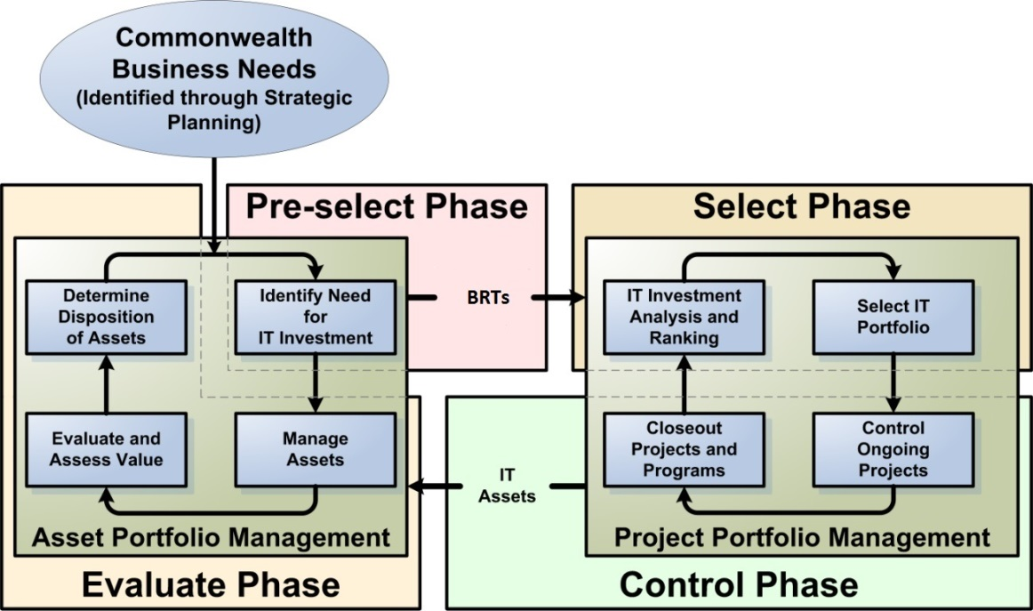

Figure 5: IT portfolio management process within the ITIM lifecycle

7.3 Commonwealth Project Portfolio Management Process
The Commonwealth Project Portfolio Management (PPM) process is a cycle of activities that address Code of Virginia (§2.2-2007) requirements and are aligned with industry best practices. Commonwealth executive branch agencies use these activities to govern and execute current or proposed Commonwealth IT projects or procurements. The fundamental objective of the PPM cycle is to determine the optimal mix and sequencing of IT projects and control their delivery to best achieve the Commonwealth’s overall goals. PPM supports ongoing measurement of the project portfolio so each related IT investment can be monitored for its relative contribution to business goals and improving business value.

Execution of the PPM process involves conducting the following ITIM activities:

- Analyze and rank IT investments, as described in Section 6.3.1.2
- Select IT investment portfolio, as described in Section 6.3.1.3
- Control projects and procurements, as described in Sections 6.4.1.1 and 2
- Complete procurements and close projects, as described in section 6.4.1.3

7.4 Capability and Technology Management Process
Capability and Technology Management (CTM) is a cycle of activities aligned with industry best practices that Commonwealth executive branch agencies use for evaluating the performance of existing IT assets and linking continuing investments in those IT assets to business needs. The objective of the CTM cycle is to realize optimal value from continuing IT investments. CTM supports ongoing measurement of IT investment performance to ensure the asset’s contribution to business goals and improving business value.

Execution of the CTM process involves conducting the following ITIM activities:

- Measure IT asset performance.
During this activity agencies systematically collect, record, and report information on the performance of all IT assets, whether managed through the IT Partnership or managed by the agency. All IT assets should have service level performance measures assigned to them, and the performance measures should be directly tied to the business needs of the agency and the value the investment provides to the Commonwealth..
- Conduct IT asset and service evaluation, as described in Section 6.5.1.2
- Determine IT asset disposition, as described in Section 6.5.1.3

8. STAKEHOLDER RESPONSIBILITIES

8.1 Purpose
This Section will define the stakeholder responsibilities in each of the four ITIM phases. These roles and responsibilities are assigned to individuals, and may differ from the COV role title or working title of the individual’s position. Individuals may be assigned multiple roles, as long as the multiple role assignments provide adequate separation of duties, provide adequate protection against the possibility of fraud, and do not lead to a conflict of interests.

8.3 Commonwealth Chief Information Officer (CIO)
Pre-select
- Define criteria for evaluating Commonwealth IT investments.
- Develop a technology investment management standard.
- Review and approve all state agency and public institution of higher education information technology plans.
- Evaluate and recommend approval or disapproval of the IT components of agency strategic plans or IT investment changes to agency strategic plans.
- Develop the six-year Commonwealth Strategic Plan for Information Technology, update the Plan annually, and submit to the Secretary of Administration for approval.
- Plan and forecast future needs for information technology and conduct studies and surveys of organizational structures and best management practices of information technology systems and procedures.
- Assist state agencies and public institutions of higher education in the development of information management plans and the preparation of budget requests for information technology.
- Develop and approve statewide technical standards for information technology and related systems.
- Define the Commonwealth’s “as-is” and “to-be” Enterprise Architecture.

Select
- Review agency IT budgets and make recommendations to the Department of Planning and Budget (DPB).
- Build and maintain a Commonwealth Technology Portfolio (CTP) to include investments planned and underway.
- Review and approve for planning all Major and Non-major IT Projects and procurements over $250,000.
- Review Commonwealth IT portfolio analysis, accompanying documents, and the recommended Commonwealth IT portfolio and submit the annual Recommended Technology Investment Projects (RTIP) Report, with recommended priorities for funding the projects, to the Secretary of Administration,, and the Joint Commission on Technology and Science.

Control
- Review and grant approval or disapproval of Commonwealth IT projects and procurements over $250,000.
- Appoint an Internal Agency Oversight Committee (IAOC) for each Major IT project to provide oversight and direction to the project for which they are chartered and participates (or appoints a representative) as a voting member on the Proponent Secretariat Oversight Committee (PSOC) for Major IT projects.
- Approve, as a part of the project plan, the target asset performance measures to be used in the asset’s Post Implementation Review (PIR).

Evaluate
- Evaluate the needs of agencies in the Commonwealth with regard to (i) a consistent, reliable, and secure information technology infrastructure, (ii) existing capabilities with regard to building and supporting that infrastructure, and (iii) recommended approaches to ensure the future development, maintenance, and financing of an information technology infrastructure befitting the needs of state agencies and the service level requirements of its citizens; and
- Produce a monthly status report on partnership infrastructure projects to provide scope, schedule, cost, risk, and performance measure information.

8.4 Information Technology Advisory Council (ITAC)
Throughout the ITIM lifecycle, advise the CIO on assessing and meeting the Commonwealth's business needs through the application of information technology, establishing priorities for the use of information technology for state agencies in the executive branch of state government, the adoption of statewide architecture, technical, and data standards for information technology and related systems, and other matters brought to the Council by the CIO.

8.5 Commonwealth Project Management Division (PMD)
Pre-select
- Monitor agency and public institution of higher education implementation of information management and information technology plans and periodically report findings to the CIO.

Select
- Provide ongoing assistance and support to state agencies and public institutions of higher education in the development of information technology projects.
- Review agency IT investments and recommend project or stand-alone IT procurement approval or disapproval to the CIO.
- Participate in review and approve agency IT budget recommendations to the CIO.

Control
- Provide oversight and governance on all Commonwealth IT Projects;
- For Commonwealth projects, recommend approval or disapproval to the CIO for Project Initiation Approval (PIA).
- Provide appropriate reports to the CIO and in accordance with the Code of Virginia (§2.2-2017).
- Ensure projects are being run in accordance with statewide technical and data standards for information technology and related systems.
- Manage the project close-out activities as directed in the Commonwealth Project Management Standard.

8.6 Commonwealth IT Investment Management Division (ITIMD)
Pre-select
- Evaluate all IT investments that qualify as Commonwealth Technology Portfolio investments according to approved criteria.
- Every two years, as part of the budget process, evaluate agency and tier 1 public institution of higher education Information Technology Strategic Plans and recommend approval or disapproval to the CIO.
- Ensure Executive Branch agencies and public institutions of higher education under oversight and governance of the CIO have a CIO-approved ITSP.
- Review agency and public institution of higher education information management and information technology plans and recommend approval or disapproval to the CIO.
- On an ongoing basis, evaluate IT investment changes to agency and public institution of higher education under governance and oversight of IT strategic plans and recommend for approval or disapproval to the CIO.

Select
- Submit recommendation to the CIO for Investment Business Case (IBC) submissions for Commonwealth projects.
- Coordinate governance review and recommend for approval to the CIO agency Procurement Business Alignment (PBA) submissions for Commonwealth procurements.
- Evaluate, score, and rank all major IT projects according to the approved CIO criteria and submit a recommendation for funding to the CIO.
- Prepare the annual RTIP report and provide a quarterly update.
- Obtain CIO approval of the RTIP report with recommended priorities for funding projects.
- Review and recommend for approval or disapproval agency Investment Business Case (IBC) submissions for Commonwealth projects.
- Participate in review and approve agency IT budget recommendations to the CIO.

Control
- On behalf of the CIO, support agency use of a Commonwealth Technology Portfolio that includes agency IT projects.
- Maintain and update quarterly a list of major information technology projects that are active or are expected to become active in the next fiscal year and have been approved and recommended for funding by the CIO. Make such list publicly available on the VITA website and submit the quarterly updates to the Chairmen of the House Appropriations and Senate Finance Committees and the Director, Department of Planning and Budget.

Evaluate
- On behalf of the CIO, support agency use of a Commonwealth Technology Portfolio that includes operational risks and issues.
- Participate in IT project Post Implementation Reviews (PIR) as directed in the Commonwealth Project Management Standard.

8.7 Commonwealth Secretariats
Pre-select
- Establish business priorities for their Secretariat.

Select
- Prioritize the Secretariat’s Major IT Projects.

Control
- Chair Secretariat Oversight Committees established for Major IT projects
- Review, approve, and comment on monthly status reports, baseline adjustments greater than 10%, and IV&V reports for each active Major project as needed.

Evaluate
- Monitor agency use of IT in support of the delivery of stakeholder services.

8.8 Commonwealth Agencies
Pre-select
- Identify business needs and document in Commonwealth or agency technology portfolio with a Business Requirements for Technology (BRT) entry.
- Prioritize potential IT investments.
- Document target performance metrics and identify business value for potential projects in Investment Business Cases.
- Research possible enterprise or collaboration opportunities for the agency; and
- Update the Agency Strategic Plan and Agency Technology Portfolio with IT investment business cases, identified business needs, and identified value for each potential investment.
- At least biennially the agency head shall designate an agency head/AITR(s) for the Commonwealth Technology Portfolio (CTP) system, and provide the person’s name, title, and contact information to ITIMD via e-mail.

Select
- Establish a process for evaluating, scoring, and ranking IT investments for the agency.
- Prioritize agency IT Projects.
- Annually Agency Head or their designated representative must certify Major IT Project Information and IT Strategic Planning Information for their Agency within the Commonwealth Technology Portfolio.

Control
- Translate business value into asset performance measures.
- Develop detailed project plans and execute projects as directed in the Commonwealth Project Management Standard.
- Develop applications and application modifications in accordance with statewide technical and data standards for information technology and related systems.
- Prepare and submit monthly status reports, requests for baseline adjustments greater than 10%, and IV&V reports for each Major IT Project (as scheduled).

Evaluate
- Conduct Post Implementation Reviews on IT projects 6 to 12 months after the IT investment has been implemented using the asset performance measures established in the Control Phase.
- Use asset performance measures to measure the business value, cost, systems performance, technical relevance (EA), and risk of the agency’s IT assets.
- Document IT asset performance using industry benchmarks, the performance metrics identified by the agency, the agency’s strategic plan, and the Commonwealth’s performance measurements.
- Analyze gaps between current business needs and performance of IT assets; and
- Make a determination to maintain, migrate, improve, or retire each IT asset in the agency technology portfolio.

8.9 Commonwealth Programs
Pre-select
- Advise Secretariats and agencies on completion of Business Requirements for Technology, Investment Business Case, and Procurement Business Alignment entries for potential IT investments that can be managed within the scope of the program.

Select
- Provide evaluation, scoring, ranking and investment business case or procurement business alignment information for IT projects and procurements that can be managed within the program as needed.

Control
- Manage projects within the scope of the program in a coordinated way to obtain business value and control not available from managing the projects individually.

Evaluate
- While the Program is operational, for IT projects managed by the Program, conduct Post Implementation Reviews 6 to 12 months after the IT investment has been implemented using the asset performance measures established in the Control Phase.
- While the Program is operational, use asset performance measures to measure the business value, cost, systems performance, technical relevance (EA), and risk of the IT investments implemented by the Program.
- While the Program is operational, document the performance of IT assets implemented by the Program using industry benchmarks, the performance metrics identified during the Control Phase, the customer agency’s strategic plans, and the Commonwealth’s performance measurements.

APPENDIX A – SUMMARY OF AGENCY RESPONSIBILITIES
Scope
This standard is applicable to all Executive Branch state agencies and institutions of higher education (hereinafter collectively referred to as "agencies") that are responsible for the management, development, purchase and use of information technology resources in the Commonwealth of Virginia. This standard does not apply to research projects, research initiatives or instructional programs at public institutions of higher education. (Preface)
Agency Maintenance of Portfolio and Resource Management (PRM) in CTP
The PRM component in CTP is the current repository for capturing and managing all Commonwealth IT investments: projects, procurements, and agency strategic plans. All projects and procurements equal to or greater than $250,000 as well as agency IT Strategic Plans (ITSP) are subject to Commonwealth oversight and governance and must reside in CTP. (Section 4.3.2)
Agency Maintenance in the Capability and Technology Management (CTM) Component in Planview
The CTM component in Planview is the current repository for cataloging IT assets, including applications, data, and software tools used by executive branch agencies to support their businesses. Agency entries in CTM must be kept accurate and up to date as changes occur. Certification of the data in Archer such that it is reflected as such in the CTM component is required as part of the agency IT Strategic Planning process. (Section 4.3.2)
Agency responsibilities in each of the four ITIM phases (section 8.8)
Pre-select
- Identify business needs and document in Commonwealth or agency technology portfolio with a Business Requirements for Technology (BRT) entry.
- Prioritize potential IT investments.
- Document target performance metrics and identify business value for potential projects in Investment Business Cases.
- Research possible enterprise or collaboration opportunities for the agency.
- Update the Agency Strategic Plan and Agency Technology Portfolio with IT investment business cases, identified business needs, and identified value for each potential investment.
- At least biennially the agency head shall designate an agency head/AITR(s) for the Commonwealth Technology Portfolio (CTP) system, and provide the person’s name, title, and contact information to ITIMD via e-mail.
Select
- Establish a process for evaluating, scoring, and ranking IT investments for the agency.
- Prioritize agency IT Projects.
- Annually Agency Head or their designated representative must certify Major IT Project Information and IT Strategic Planning Information for their Agency within the Commonwealth Technology Portfolio.
Control
- Translate business value into asset performance measures.
- Develop detailed project plans and execute projects as directed in the Commonwealth Project Management Standard.
- Develop applications and application modifications in accordance with statewide technical and data standards for information technology and related systems.
- Prepare and submit monthly status reports, requests for baseline adjustments greater than 10%, and IV&V reports for each Major IT Project (as scheduled).
Evaluate
- Conduct Post Implementation Reviews on IT projects 6 to 12 months after the IT investment has been implemented using the asset performance measures established in the Control Phase.
- Use asset performance measures to measure the business value, cost, systems performance, technical relevance (EA), and risk of the agency’s IT assets.
- Document IT asset performance using industry benchmarks, the performance metrics identified by the agency, the agency’s strategic plan, and the Commonwealth’s performance measurements.
- Analyze gaps between current business needs and performance of IT assets.
- Make a determination to maintain, migrate, improve, or retire each IT asset in the agency technology portfolio.

APPENDIX B – LINKS TO RESOURCES
4.2.2 Technology Business Plan:

https://www.vita.virginia.gov/media/vitavirginiagov/it-governance/pdf/CommonwealthTechnologyBusinessPlan.pdf
4.2.3 Commonwealth Strategic Plan for Information Technology
https://www.vita.virginia.gov/policy--governance/it-investment-management/cov-strategic-plan-for-it/itsp---2017-update/
4.2.4 Enterprise Information Architecture
https://www.vita.virginia.gov/media/vitavirginiagov/it-governance/ea/pdf/EA_StandardEA225-15-2.pdf

