**COMMONWEALTH OF VIRGINIA**



**<Name> Program  
Program Architecture (ARC) Plan**

**<Date>**

**Virginia Information Technologies Agency (VITA)**

**Program Architecture Plan Template v1**

**Publication Version Control**

| **Version** | **Control No.** | **Date** | **Revision Description** | **Prepared By:** |
| --- | --- | --- | --- | --- |
| Program Architecture (ARC) Plan_v1 |  |  | First draft |  |
|  |  |  |  |  |
|  |  |  |  |  |
|  |  |  |  |  |

TABLE OF CONTENTS

1. Document Change Control 4

2. Related Documentation 4

2.1. Applicable Program-Related Documents 5

2.2. Applicable Standards, Policies, Guidelines, and Strategic Plans 5

2.3. Applicable Industry Sources 5

3. Governing Federal Laws and Regulations 5

4. Governing Commonwealth of Virginia Policies, Standards, and Guidelines 6

5. Industry Resources 7

6. Introduction 7

7. Program Architecture Plan Overview 7

7.1. Meta Architecture 8

7.2. Roles and Responsibilities 8

7.3. Existing Program Architecture 12

8. Proposed Solution Architecture(s) 13

8.1. Design Rationale and Goals 13

8.2. Design Trade-off Analysis 14

8.3. Program Architecture Assumptions 14

8.4. Program Architecture Constraints 14

8.5. Program Architecture Risks 14

8.6. Enterprise Business Architecture 14

8.7. Enterprise Solutions Architecture 15

8.8. Enterprise Technical Architecture 16

8.9. Enterprise Information Architecture 21

9. Website Considerations 27

10. Procurement Considerations 27

11. Testing Considerations 27

12. Training Considerations 27

13. Organizational Change Management Considerations 27

14. Business Process Impacts 28

15. Architecture Implementation Plan 28

16. Approvals 29

17. Appendices 30

17.1. Program Architecture Plan Change Control Log 31

17.2. Acronyms 32

**List of Figures**

No table of figures entries found.

**List of Tables**

No table of figures entries found.

*General Explanation: This template represents the full scope of an architecture structure that could possibly be conceived in the Commonwealth of Virginia. The Program Management Standard indicates that this is plan is required, but the Project Management Division (PMD) must come to an agreement on what constitutes “just right” documentation in any given plan. For example, some sections are “N/A” while other sections will apply. Also, additional sections may be required depending on what the architecture comprises. The idea is to be as complete as possible without overdoing it. How elaborate an applicable section needs to be is discretionary depending on the complexity of the Program and the concurrence of PMD, the Program Management Office (PMO), and the Sponsor (approver).*

*It is not intended for the PMO to complete this document in its entirety on its own unless a Program-level Architect is assigned to the Program. In either case, other technical resources will need to be involved and given writing assignments to complete sections pertinent to their area of expertise or Component Project. Also note that for some sections, more than one Project may have an input while in other areas, they may be silent as it does not pertain to them. In such cases it is best to state that “Project B” and “Project C” are not concerned with this technology issue to ensure that lack of content does not imply noninvolvement. A negative answer is best in these cases. Delete this and other guidance blocks denoted in italics in this document.*

# Document Change Control

After this document is accepted by the Program Management Office (PMO), the approved version is the baseline. All baseline version document changes will be based on an approved change control procedure, as outlined in the Program Change and Configuration Management Plan.

A Change Control Process will be implemented to record significant changes within this document. Significant changes are those that will change the course of the Program and have an impact on the Program’s documented plans and approach.

The updated Change Control Log will be routed to the signatories for acknowledgement and approval. If all signatories attend an oversight committee forum, Program Architecture Plan Change Log approvals can occur there, and recorded in the minutes.

Once approved, the changes will be recorded in the Program Architecture Plan Change Control Log in the Appendix and a summary line will be added to the Publication Version Control table in the front of this plan.

|  |
| --- |
| **C:\Documents and Settings\jsj15756\Local Settings\Temporary Internet Files\Content.IE5\UCJ72LZ8\MP900398863[1].jpgLesson Learned/Best Practice**  It is a best practice to begin change control after the drafted plan is finalized. |

# Related Documentation

Related documents include Program-specific documentation, Commonwealth of Virginia standards, policies, guidelines, strategic plans, and industry best practices.

## Applicable Program-Related Documents

Applicable documents are those documents related to the Program. The specified parts of the applicable documents carry the same weight as if they were stated within the body of this document. The following documents are applicable to the Program.

* Program Governance and Quality Management Plan
* Program Communications Management Plan
* Program Post Implementation Review Plan
* Program Risks and Issues Management Plan
* Program Resource Management Plan
* Program Financial Management Plan
* Program Procurement Management Plan
* Program Change and Configuration Management Plan
* Program Architecture Plan
* Program Organizational Change Management Plan
* Program Implementation and Transition to Operations Management Plan

## Applicable Standards, Policies, Guidelines, and Strategic Plans

* Information Technology Resources Management (ITRM) Information Technology Investment Management (ITIM) Standard CPM 516-01
* Glossary of Terms and Acronyms
* ITRM Project Management Standard
* ITRM Program Management Standard
* ITRM Project Manager Selection Criteria
* Chief Information Officer (CIO) and Agency Strategic Plans

## Applicable Industry Sources

* Architectural Blueprints – The “4+1” View Model of Software Architecture by Philippe Kruchten, Rational Software Corporation
* Information Technology Infrastructure Library (ITIL) Framework
* Gartner, Inc.
* Project Management Institute

# Governing Federal Laws and Regulations

*Explanation: The design, operation, and management of information and related assets are subject to statutory, regulatory, and contractual architectural and security requirements. Compliance with mandated requirements is necessary to avoid penalties and ensure on-going operations. This section covers Federal laws and regulations.*

*Create a list of laws or regulations establishing specific requirements for the confidentiality, integrity, or availability of the data in the system. Add or amend the list as needed.*

1. *Health Insurance Portability and Accountability Act of 1996 (HIPAA)*
2. *Internal Revenue Service 1075*
3. *Privacy Act of 1974*
4. *Payment Card Industry (PCI) Standard*
5. *Rehabilitation Act of 1973*
6. *§ 508 Amendment to the Rehabilitation Act of 1973*
7. *Federal National Security Standards*
8. *Federal Enterprise Architecture Business Reference Model*
9. *Freedom of Information Act (FOIA)*

# Governing Commonwealth of Virginia Policies, Standards, and Guidelines

The Program Architecture (ARC) Plan is governed by many Commonwealth of Virginia (COV) policies, standards, and guidelines. They are listed here to guide the reader to the source material to ensure relevancy and currency, and guarantee all areas are considered in this plan’s development. Legal requirements include, but are not limited to: state statute, statewide and agency policy, regulations, contractual agreements, intellectual property rights, copyrights, and protection and privacy of personal information. A very good reason to list the governing policies, standards and helpful guidelines is to validate the currency of these documents. Use the list to check if a more current dated document is posted to the VITA website. If items in the below list are not current, update the list and ensure a thorough review of the updated governance document(s).

**Enterprise Architecture**

* Enterprise Architecture Policy (EA 200-02) (07/03/2012)
* EA Change – Exception Request Form (08/24/2010)
* COV ITRM Enterprise Architecture Standard (EA 225-09) (02/13/2013)
* Enterprise Data Standards Repository
* EA Exception Request Log (08/12/2010)
* *Code of Virginia* §2.2-3803 (B) Internet Privacy Policy and Statement
* Virginia Public Records Act

**Geographic Information Systems (GIS)**

* Model Virginia Map Accuracy Standards Guideline (ITRM Guideline OTH701-00) (03/15/2009)

**Information Security Policy**

* IT Information Security Policy (SEC 519-00) (07/24/2009)

**Information Security Standards**

* IT Information Security Standard (SEC501-07.1) (01/28/2013)
* IT Security Audit Standard (SEC502-02.2) (01/06/2013)
* IT Standard Use of Non-Commonwealth Computing Devices to Telework (SEC511-00) (07/01/2007)
* Removal of Commonwealth Data From Electronic Media Standard (SEC514-03) (03/15/2008)
* Secure Remote Access to Online Court Documents Standard (SEC503-02) (03/28/2005)
* Virginia Real Property Electronic Recording Standard (SEC505-00) (05/01/2007)

**Information Security Guidelines**

* Information Security Facilities Security Guideline (SEC517-00) (04/27/2009)
* IT Contingency Planning Guideline (SEC508-00) (04/18/2007)
* IT Data Protection Guideline (SEC507-00) (07/02/2007)
* IT Logical Access Control Guideline (SEC509-00) (04/18/2007)
* IT Personnel Security Guideline (SEC513-00) (02/15/2008)
* IT Risk Management Guideline (SEC506-01) (12/11/2006)
* IT Risk Assessment Instructions – Appendix D (SEC506-01) (112/14/2006)
* IT Security Audit Guideline (SEC512-00) (12/20/2007)
* IT Security Threat Management Guideline (SEC510-00) (07/01/2007)
* IT Systems Asset Management Guideline (SEC518-00) (04/27/2009)
* IT Systems Security Guideline (SEC515-00) (07/17/2008)
* Public Kiosk Security Guidelines

# Industry Resources

# Introduction

*Explanation: The Program Architecture Plan (ARC) provides the overall Program technical context. At the Program Management Office (PMO) level, the success of the Program is dependent upon ensuring a consistent architecture is constructed and change management across architectural components is executed properly. It includes the existing system architecture, solution architecture, security plan, data management and migration plans, and considerations such as testing, training, implementation, etc. Each of these areas will be addressed in separate sections within this overarching plan.*

*The architecture defines how the system/product will be constructed, describing what the critical components are and how they fit together, from a high-level, logical perspective. The architecture must be documented in a way that clearly identifies the logical layers of the systems, the specific subsystems that compose the layers, and their responsibilities and interfaces. A sound architecture allows reuse of design components between projects.*

*As part of this overarching plan, information security must be addressed. Information security is the protection of information from a variety of threats to ensure business continuity, minimize business risk, and maximize return on investments. Information security is achieved through planning, executing, monitoring and controlling policies, processes, and procedures.*

*The data management and migration plans describe the strategy, preparation, and specifications for managing and migrating data from a source system or systems to a target system or systems. The plans describe the overall approach, assumptions, constraints, risks, and data processes.*

# Program Architecture Plan Overview

*Explanation: The ARC Plan is the Program and Component Projects’ architectural elements baseline description as it relates to the delivery of Program objectives. This plan sets the stage for developing the Program work breakdown structure, as it shows the relationships among the various Program technical areas. It builds on the initial Program scope and requirements, defining their interactions and dependencies. As the plan is being developed, trade off analysis between different solutions may need to be discussed since each tradeoff solution has quality, schedule, and cost implications.*

*Another purpose of the ARC Plan is to identify any conflicts in architecture, design, tool usage, etc. for the Program and ensure those issues are resolved.*

*The plan shows how the Program will be at certain stages and defines how stakeholders will know the implementation of the architecture was successful. Once the plan is approved, the baseline is established for developing resource, effort, and cost estimates. As the Program progressively matures, so will the architecture. This iterative plan should be reviewed periodically by the PMO, other key stakeholders, and governance members at various phases in the Program’s lifecycle.*

*It is highly recommended that during the detailed planning phase, key technical and business resources review the policies, standards, and guidelines as a planning committee, discussing thoroughly each page to ensure no topic is missed in developing this plan. Although it sounds like overkill, in the long run, this technique will be viewed as a best practice.*

## Meta Architecture

*Explanation: Specify in this section your architectural vision, key principles, special styles/conventions to be followed, concepts and key assumptions that will affect end product design. Focus on the high-level decisions that will strongly influence the system structure. This section should rule out certain structural choices and guide your decisions and tradeoffs among others.*

*Where applicable, classify technology solutions in terms of strategic, emerging, transitional/contained and obsolescent/rejected. Definitions of each of these terms are provided in the COV ITRM Enterprise Architecture Standard in the Definition of Key Terms Section. Add notes to describe the chosen technology for that specific section.*

## Roles and Responsibilities

List the architecture, security, and data resource roles and responsibilities. Use the below table or create your own. The roles listed in the table are examples and/or addressed in applicable standards.

| IT System Name, Acronym, and Designation |  | | |
| --- | --- | --- | --- |
| Role | Responsibility | Name | Reports to (Name and Title) |
| Chief Information Officer (CIO) | Directs the development of policies, procedures and standards for architecture, security, and data. |  |  |
| Chief Information Security Officer (CISO) | Develops and coordinates the COV Information Security Program. |  |  |
| Chief Architect | Provides governance and oversight for the architecture; develops policies, standards, and guidelines for architecture. |  |  |
| Agency Head | Oversees Agency IT Architecture, Security, and Data Programs for the Agency. |  |  |
| Program Architect | Assesses Component Project architecture at the Program level. Is primarily responsible for ensuring a consistent architecture across all Component Projects. |  |  |
| Software Architect | Invents strategic solutions that the technical development team can use to create solutions. |  |  |
| Information Security Officer (ISO) | Develops and manages the agency’s information security program. |  |  |
| Privacy Officer | Provides guidance on privacy laws. This is a necessary position if required by law or regulation and is optional for when not required by law or regulation. |  |  |
| System Owner | Is the agency business manager responsible for operations and maintenance of an IT system. Responsible for the overall security of the IT system. Accountable to the Agency Head. |  |  |
| Data Owner | Spreads IT security awareness to data users. Develops any additional local requirements, guidelines and procedures needed to protect data; is the owner of the Data Management and Migration Plans, if any. Evaluates and classifies data sensitivity, defines protection requirements, communicates data protection requirements to the System Owner, and defines data access requirements. |  |  |
| System Administrator | Administers day-to-day IT systems. Implements requirements of the IT Security Management Program. The System Administrator is an analyst, engineer, or consultant who implements, manages, and/or operates a system or systems at the direction of the System Owner, Data Owner, and/or Data Custodian. |  |  |
| Data Custodian | Protects data from unauthorized access, alteration, destruction, or usage and in a manner consistent with COV IT security policies and standards. Data Custodians are individuals or organizations in physical or logical possession of data for Data Owners. |  |  |
| .NET/J2EE/PHP Developer | Designs, builds, and unit tests the solutions; fixes legitimate defects found by testers. |  |  |
| Database Developer | Creates the database schema; designs, builds, and unit tests stored procedures; fixes legitimate database defects found by testers. |  |  |
| Web Developer / Agency Webmaster | Creates Websites using the Virginia Common Template and requirements based on COV ITRM Accessibility Standard (GOV103-00) except for exempt agencies. |  |  |
| Business Analyst | Documents use cases, business processes, and data model design. |  |  |
| User Interface Designer | Designs the user interface. |  |  |
| Tester | Executes use cases developed by the Business Analyst; for each defect, the tester documents the defect, assigns it to a developer, re-tests the functional area when updated, and either assigns another defect or closes the existing defect record if resolved. User Acceptance Testers should be from a pool of system end users. |  |  |
| Deployment Specialist | Builds and deploys the application(s) using configuration control tools; may also build and deploy tasks using automated scripts. |  |  |
| Technical Writer | Documents the iterations of the Program Architecture Plan. |  |  |
| Trainer | Teaches end users how to use the application(s); may use the use cases as a training source. |  |  |

## Existing Program Architecture

*Explanation: Document the existing, “as is,” Program Architecture. If nothing exists in the “as-is” state, briefly state so here and delete the subsystem paragraphs that follow. Please note the following graphic comes from the COV ITRM Enterprise Architecture Standard. It is repeated here as a reminder to guide you in developing the “as is” architecture.*

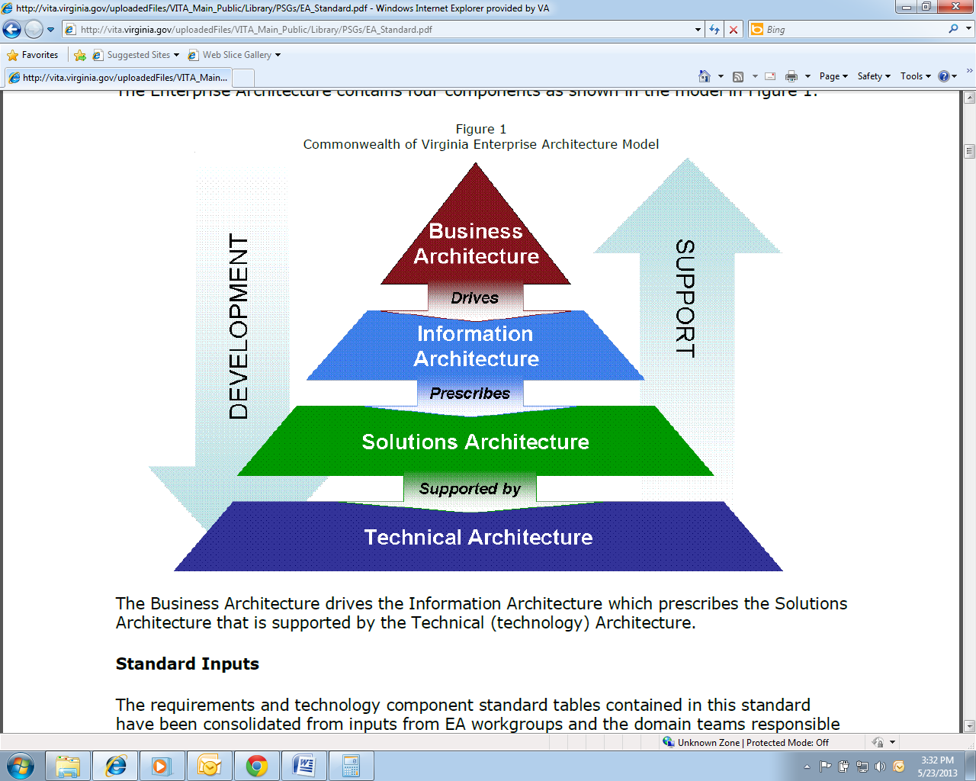

# Proposed Solution Architecture(s)

*Explanation: Document the proposed solution architecture – the future state of the overall system structure based on the COV Enterprise Architecture components of Business Architecture, Solutions Architecture, Technical Architecture, and Information Architecture.*

## Design Rationale and Goals

*Explanation: Document the design rationale and goals with an explanation of each. Use these example goals and/or add your own based on the Program’s needs.*

* *User Friendly*
* *Ease of Use*
* *Reliability*
* *High Performance*
* *Minimum Number of Errors*
* *Security*
* *Completeness of Functionality*
* *Code Reuse*
* *Easier Integration*

## Design Trade-off Analysis

*Explanation: Document any design trade-off analysis conducted. This is important because it may need to be revisited many times throughout the Program’s lifecycle as new information comes to light.*

## Program Architecture Assumptions

*Explanation: This section identifies the statements believed to be true for the program architecture to be considered successful. These may concern such issues as related software or hardware, operating systems, etc.*

## Program Architecture Constraints

*Explanation: This section identifies any limitations that must be taken into consideration when designing and building the Program architecture solution.*

## Program Architecture Risks

*Explanation: Describe any risks associated with the solution Program architecture.*

## Enterprise Business Architecture

*Explanation: This section of the ARC Plan is encapsulated in other Program Management Planning documents. Refer to the following Program sub-plans when planning the Program architecture:*

* *Program Charter*
* *Program Post Implementation Review Plan (PIR)*
* *Program Governance and Quality Management Plan (GQM)*
* *Scenarios – Use Cases*
* *Decomposed requirements documentation*
* *Commonwealth of Virginia Enterprise Architecture Library located at the following URL: (*[*http://www.vita.virginia.gov/oversight/default.aspx?id=365*](http://www.vita.virginia.gov/oversight/default.aspx?id=365)*) that includes COV’s Enterprise Business Architecture (EBA) -- static report and ad hoc query interface for extracting agency specific EBA data and reports*

*Document any business architecture considerations such as it relates to business strategy, service-oriented architecture, business processes, how information needs to be reported, as well as gaps and inefficiencies based on these Program-level artifacts and their relationship to each other. Note this architectural area is based on the cross-agency lines of business rather than individual agency functions.*

## Enterprise Solutions Architecture

*Explanation: The COV ITRM Enterprise Architecture Standard, Chapter 4, states that the Enterprise Solutions Architecture “provides the framework/model and methodology that supports the transition from silo-based, application-centric and agency-centric information technology investments to an enterprise approach where solutions are designed to be flexible.” To that end, keep the overarching strategy goals in mind when creating the future-state of the enterprise architecture.*

### Proposed Subystem(s) Operational Status

*Explanation: Indicate the current operational status of the system(s). If more than one status is selected, list which part of the system is covered under each status. Refer to the following descriptions to identify which category(ies) the architecture belongs.*

* *Part of the proposed architecture may be currently operational such as an authentication service; in this case, the service would be considered “operational.”*
* *If part of the architecture is underway under another Program, for example, it would be considered “under development.”*
* *If the architecture exists, but it is going to take much to modify it to work in the future architecture, then identify it in the “Major Modification” column.*
* *If the architecture is a brand new concept, never before developed, and it does not exist in the Commonwealth’s inventory, then identify it as “Not Developed.”*

|  |  |  |  |
| --- | --- | --- | --- |
| **Operational** | **Under Development** | **Major Modification** | **Not Developed** |
|  |  |  |  |
|  |  |  |  |
|  |  |  |  |
|  |  |  |  |

### A Subsystem

*Explanation: Briefly explain this subsystem and its purpose. Replace the letter “A” with the appropriate subsystem name. Include any assumptions and constraints, any interfaces with other subsystems, its layer schematic, and any layer dependencies among Component Projects requiring management and oversight at the Program level. Include any subsystem public interfaces exposed to end users and any known operating system dependencies such as run-time libraries, classes, etc. if the architecture is dependent on their services.*

### B Subsystem

*Explanation: Briefly explain this subsystem and its purpose. Replace the letter “B” with the appropriate subsystem name. Include any assumptions and constraints, any interfaces with other subsystems, its layer schematic, and any layer dependencies among Component Projects requiring management and oversight at the Program level. Include any subsystem public interfaces exposed to end users and any known operating system dependencies such as run-time libraries, classes, etc. if the architecture is dependent on their services.*

### C Subsystem

*Explanation: Briefly explain this subsystem and its purpose. This subsystem may or may not coincide with the current “C Subsystem.” Replace the letter “C” with the appropriate subsystem name. Include any assumptions and constraints, any interfaces with other subsystems, its layer schematic, and any layer dependencies among Component Projects requiring management and oversight at the Program level. Include any subsystem public interfaces exposed to end users and any known operating system dependencies such as run-time libraries, classes, etc. if the architecture is dependent on their services.*

### D Subsystem

*Explanation: Briefly explain this subsystem and its purpose. This subsystem may or may not coincide with the current “D Subsystem.” Replace the letter “D” with the appropriate subsystem name. Include any assumptions and constraints, any interfaces with other subsystems, its layer schematic, and any layer dependencies among Component Projects requiring management and oversight at the Program level. Include any subsystem public interfaces exposed to end users and any known operating system dependencies such as run-time libraries, classes, etc., if the architecture is dependent on their services.*

## Enterprise Technical Architecture

*Explanation: The Enterprise Technical Architecture Model is the one described in the COV ITRM Enterprise Architecture Standard. At the heart of this model are eight technical domains:*

1. *Security*
2. *Enterprise Systems Management*
3. *Information*
4. *Database*
5. *Application*
6. *Integration*
7. *Platform*
8. *Networking and Telecommunications*

*The technical architecture model representation is included here as a reminder of the areas to address in this section.*

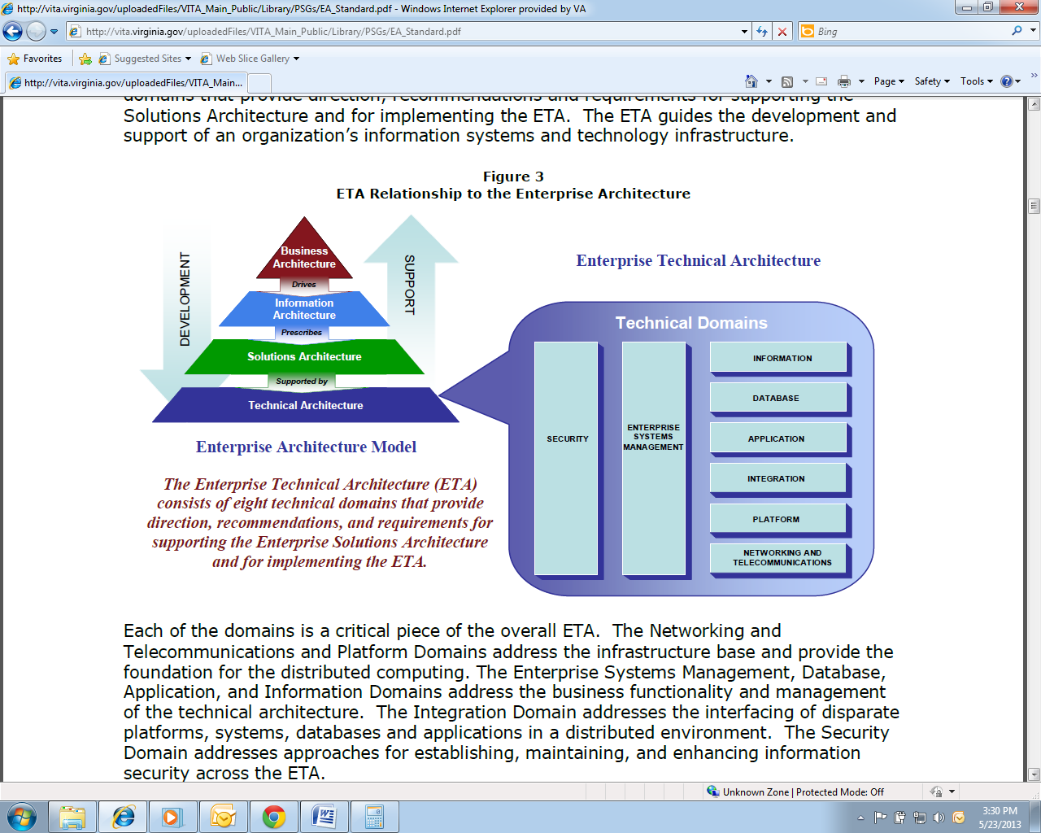

### Enterprise Technical Architecture by Domain

*Explanation: Use the COV: Enterprise Technical Architecture (ETA) Checklist to highlight each domain’s critical information needing oversight at the Program level. Document any dependencies across subsystems within the lines of business. Where applicable, address hardware and software mapping in terms of strategic, emerging, transitional/contained, and obsolescent/rejected categories.*

#### Security Domain

*Explanation: The security domain section is based on the COV security standards. Consider each of the following topics when creating this section: Risk Management (Vulnerabilities, Threats, and Risks), IT Contingency Planning, IT Systems Security, Logical Access Control, Data Protection, Facilities Security, Personnel Security, IT Asset Management, Communications and Operations Management, Access Control, Information Security Incident Management, and Business Continuity Management. Note to use the COV Information Security Policy and Standard Exception Request Form if there are valid reasons for requesting agency/security exceptions. Ensure to address risk assessments and security audits as separate sections.*

##### Risk Assessment

*Explanation: Describe the risk assessment process in terms of the Program. Develop a risk assessment schedule for planning purposes. Use standards and guidelines for risk assessments.*

##### Security Audits

*Explanation: Per the Security Audit Standard, a security audit “is an independent review and examination of a...system’s [information technology] policies, records, and activities.” Controls are reviewed for adequacy and compliance; they are presented in the IT Information Security Standard.*

*Develop a security audit schedule for planning purposes, if appropriate. The overall security audit process is summarized below:*

* *Identify Security audit resources.*
* *Define a scope, schedule and audit checklist.*
* *Perform the audit.*
* *Document audit findings.*
* *Audited Agencies develop corrective Action Plans*
* *Audited Agencies provide periodic feedback to VITA on progress of outstanding corrective action plans.*

#### Enterprise Systems Management Domain

*Explanation: The Enterprise Systems Management Domain is one of the domains addressing the business functionality and management of the technical architecture. At the highest level, it involves service delivery, service support, and operations management.*

##### Service Delivery

*Explanation: Service delivery includes network monitoring, monitoring servers, applications monitoring, net-flow analyzer, troubleshooting tools, Help Desk, Asset, Storage, Wireless LAN, Event, and Performance Management. In the following sections address each area.*

##### Service Support

*Explanation: Service Support considerations are an input to any related procurements and operations and maintenance lifecycle costs. Service support covers supporting and changing subtopics.*

***Supporting – Help Desk***

*Describe who will operate the Help Desk and how communication will be managed to ensure the Help Desk has the latest information. Determine what inputs the Help Desk will need to transition to operations in a smooth manner and highlight them here and discuss in more detail in the Transition to Operations Plan.*

***Changing***

*This subtopic is an input to the Configuration and Change Management (CCM) Plan. Provide a summary paragraph alluding to the CCM Plan. Ensure the following items are addressed in the CCM Plan based on the COV ITRM Enterprise Architecture Standard including:*

* *Versioning Process and Tools.*
* *Newly developed applications that must have the code documented and maintained per the COV ITRM Enterprise Architecture Standard.*
* *Source Code Repository(ies) Identification – (reference paragraph 5.1.7 of the EA Standard).*
* *Accessible and Transferrable Repositories.*
* *Documentation assets that transition to operational use especially if training manuals, user manuals, etc., were created for Component Projects within the Program.*
* *Comply with ANSI standards according to the EA Standard.*
* *Define the following:*
  + *Artifact*
  + *Reusable Components*
  + *Configuration Item (reference pg. 5.8-4 of the COV ITRM EA Standard)*
* *When state owned or leased buildings are involved, cite it directly (reference pg. 5.51 of the COV ITRM EA Standard).*
* *See pg. 5.83 of the EA Standard for input into the CM Plan.*
* *Consider Change Management, Release Management, and Configuration Management in this sub-plan.*

##### Operations Management

*Explanation: Operations Management is different than Project Management in that there is no definitive start and end date to implement solutions, but a day-to-day accomplishment of never-ending processes. Per the EA Standard, Operations Management includes: installation, repairs, maintenance, jobs management, performance monitoring, data capture for reporting, and fault management. Operations Management, how they perform their day-to-day responsibilities, should be an input into the Transition to Operations Plan. Any considerations created as a result of this program should be documented here.*

#### Information Domain

*Explanation: The Information Domain addresses the business functionality and management of the technical architecture. It deals mainly with reporting requirements based on data warehouse, business intelligence, and other related tools. Health Information Exchange is an example topic for this* *section. The Program must follow data standards for quality and classify data according to its sensitive nature.*

*Develop a table to display the information domain deployment stack for reporting, data warehousing, and business intelligence to be used for each Component Project across the Program. The idea is to develop consistency across Commonwealth Programs. Refer to the Enterprise Architecture Standard to determine if any element within the deployment stack is transitional / contained or obsolete / rejected as what you propose to use needs to be supported/supportable; if not, then funds will need to be considered for acquiring the needed tools and talent to be classified as strategic or emerging.*

#### Database Domain

*Explanation: The Database Domain is one of the domains addressing the business functionality and management of the technical architecture. It describes the technical areas of the software systems that support storage and retrieval of data and the types of database(s) software supporting the applications. Topics to be discussed in this section include what type of database will be used (hierarchical, networked, relation, object-oriented), Other Data Access Methods, Data Recovery and Backup, Data Dictionary, Database Administration, Enterprise Information Integration (EII), database design (standards and tools), and data modeling. Follow the domain-wide requirements outlined in the COV ITRM Enterprise Architecture Standard to complete these sections.*

*Develop a table to display the database domain deployment stack for directory services, database metadata services, database access services, message formats, transfers, and integration, transaction process monitor integration and services, instant messaging, mashups, and service oriented architecture to be used for each Component Project across the Program. The idea is to develop consistency across Commonwealth Programs. Refer to the Enterprise Architecture Standard to determine if any element within the deployment stack is transitional / contained or obsolete / rejected as what you propose to use needs to be supported/supportable; if not, then funds will need to be considered for acquiring the needed tools and talent to be classified as strategic or emerging.*

#### Applications Domain

*Explanation: The Applications Domain is one of the domains addressing the business functionality and management of the technical architecture.*

##### Service-Oriented Architecture

*Explanation: Address the N-tier Service-Oriented Architecture (SOA) in this section. The SOA architecture is based upon the premise that the smallest functional unit constitutes a “service.” This enables services to be shared across architectures. Identify any existing service-oriented architecture in the state’s repository to ascertain re-use capabilities. Then identify service-oriented architecture that is needed to be built as a result of this Program.*

##### Development and Language Tools

*Explanation: Identify in table format the development and language tools used across the Program architecture.*

*Develop a table to display the development and language tools deployment stack to be used for each Component Project across the Program. The idea is to develop consistency across Commonwealth Programs. Refer to the Enterprise Architecture Standard to determine if any element within the deployment stack is transitional / contained or obsolete / rejected as what you propose to use needs to be supported/supportable; if not, then funds will need to be considered for acquiring the needed tools and talent to be classified as strategic or emerging.*

#### Integration Domain

*Explanation: The Integration Domain addresses the interfacing of disparate platforms, systems, databases and applications in a distributed environment. Its main topics are database integration and directory services. Describe the database(s) and Other Data Access Methods in accordance with the COV ITRM EA Standard.*

*Develop a table to display the integration domain deployment stack to be used for each Component Project across the Program. The idea is to develop consistency across Commonwealth Programs. Refer to the Enterprise Architecture Standard to determine if any element within the deployment stack is transitional / contained or obsolete / rejected as what you propose to use needs to be supported/supportable; if not, then funds will need to be considered for acquiring the needed tools and talent to be classified as strategic or emerging.*

#### Platform Domain

*Explanation: The Platform Domain is one of the domains addressing the infrastructure base providing the foundation for distributed computing. Adherence to platform domain standards allows data to be shared between disparate systems that do not easily communicate normally. Use the Microsoft Excel sheet for each Component Project regarding specific platforms; this will ensure consistent data collection and adherence to Enterprise Architecture information requirements.*

#### Networking and Telecommunications Domain

*Explanation: The Networking and Telecommunications Domain is one of the domains addressing the infrastructure base providing the foundation for distributed computing. This domain is integral to ensuring the future state of networking and communications in the Commonwealth of Virginia. In discussing the solution state, address facilities telecommunications, LAN, WAN, phone data, multimedia, physical location maps (cabling, pathways, and associated documentation). Please be reminded per the COV ITRM EA Standard, “that when state-owned or state-leased buildings are involved, agencies must notify the Department of General Services, Division of Engineering and Buildings. When local government-owned buildings are involved, agencies must notify the local government entity responsible for networking and telecommunications.” Enter Program-specific information into the following table.*

*Develop a table to display the platform domain deployment stack for LANs, WLANs, WAN, mobile and remote access to LANs, and wireless telecommunications to be used for each Component Project across the Program. The idea is to develop consistency across Commonwealth Programs. Refer to the Enterprise Architecture Standard to determine if any element within the deployment stack is transitional / contained or obsolete / rejected as what you propose to use needs to be supported/supportable; if not, then funds will need to be considered for acquiring the needed tools and talent to be classified as strategic or emerging.*

## Enterprise Information Architecture

*Explanation: Because of the decentralized nature of data management in the Commonwealth, it is important to assess data that can be standardized across sub-functions within lines of business. Refer to the data asset metadata repository to determine if an existing data asset(s) exists that fulfills an integral part of the data architecture and list those resources in the appropriate Enterprise Information Architecture section.*

### Data Management and Migration Plans

*Explanation: The intent of the Data Management and Migration Plans are to provide awareness of the nature of the data being used for the Program and to articulate the plans and approaches for handling that data.*

#### Data Management Plan

*Explanation: Data Management involves developing a Data Use, Data Subject Area and Information Classes, and Data Sharing Plans*

##### Data Use Plan

*Explanation: The Enterprise Architecture Group developed a Microsoft Excel workbook for data usage. Complete the Data Use section for each Component Project application associated with the Program.*

##### Data Subject Area and Information Classes

*Explanation: The Enterprise Architecture Group developed a Microsoft Excel workbook for Data Subject Area and Information Classes. Complete the Data Subject Area and Information Classes section for each Component Project application associated with the Program. Then identify what classifications of data are being either written (published) or read (subscribed) by the application. All Enterprise Architecture Review workbooks will become appendices to this Program Plan.*

##### Data Shared among Subsystems

*Explanation: Identify the common data shared among subsystems and the source of that data. Consider putting the data in a table format.*

#### Data Migration Plan

*Explanation: This Data Migration Plan describes the strategy, preparation, and specifications for converting data from source system(s) to target system(s). This plan describes the overall approach, assumptions, and processes that will be used in the data migration, tools needed to execute the conversion, and strategy for data quality assurance and control.*

##### Data Migration Scope

*Explanation: Provide a rationale for the migration and a general description of the migration effort boundaries. This may include, but not be limited to, specific system functions affected and functions/data not affected/migrated. Provide a high-level mapping of the data and data types to be migrated to the new system.*

##### Data Migration Approach

*Explanation: Describe the approach to extract, transform, clean, and load data from the source to target destinations.*

##### Data Migration Objectives

Explanation: Describe the data migration objectives.

##### Assumptions

*Explanation: This section identifies the statements believed to be true for the data migration to be considered successful. These may concern such issues as related software or hardware, operating systems, end-user characteristics, and/or the data that must be available for the migration.*

##### Constraints

*Explanation: This section identifies any limitation that must be taken into consideration prior to the data migration from the old to the new product or IT system.*

*Describe any limitations or constraints that have a significant impact on the data migration effort.*

##### Risks

*Explanation: Describe any risks associated with the data migration and proposed mitigation strategies.*

##### Migration Schedule

*Explanation: Provide a milestone schedule of migration activities to be accomplished. If appropriate, tables and/or graphics may be used to present the schedule. Ensure that this information is appropriately integrated into the overall Program schedule. The schedule should be as comprehensive as possible; however, the schedule may be revised as needed at later points in the lifecycle. Rather than providing this schedule in the table below, the schedule may be added as an Appendix and may be developed in a project management tool.*

Table 1 Data Migration Schedule

| Task # | Task Description | Begin Date | End Date | Key Person(s) Responsible | Dependencies | Milestone |
| --- | --- | --- | --- | --- | --- | --- |
| <task #> | <task description> | <mm/dd/yy> | <mm/dd/yy> | <name(s)> | <task #(s)> | <Yes/No> |
|  |  |  |  |  |  |  |
|  |  |  |  |  |  |  |
|  |  |  |  |  |  |  |
|  |  |  |  |  |  |  |
|  |  |  |  |  |  |  |
|  |  |  |  |  |  |  |
|  |  |  |  |  |  |  |
|  |  |  |  |  |  |  |
|  |  |  |  |  |  |  |
|  |  |  |  |  |  |  |
|  |  |  |  |  |  |  |
|  |  |  |  |  |  |  |

##### Data Quality Assurance and Control

*Explanation: Describe the strategy to be used to ensure data quality before and after all data conversions. Also describe the approach to data scrubbing and quality assessment of data before they are moved to the new or migrated system. Describe the manual and/or automated controls and methods to validate the migration and to ensure all data intended for migration have been migrated. Describe the process for data error detection and correction, and the process for resolving anomalies.*

##### Data Migration Preparation

*Explanation: Before data migration begins, preparation tasks should be planned.*

***Prerequisites***

*Describe all the prerequisite processes that must be completed prior to data migration. Describe specific data preparation requirements.*

***Backup Strategy***

*Describe how the source and target data baselines will be created and managed prior to any manipulation or migration. Also describe backups that may occur incrementally while stepping through the process of preparing, moving, and manipulating the data during migration. Are the backup strategies across the agencies consistent?*

***Restore Process***

*Describe the process to restore the source data if the need to revert to a previous back-up is identified at any point during the migration process. Are all the restore processes across agencies consistent?*

***Data Migration Specifications***

*Provide a cross reference of the input (source) data to be migrated to the resultant output (target) data. Also identify if any of the data are derived from other data. Provide transformation/cleansing rules for each data element and any other additional considerations.*

*Use the Data Migrations Specifications Table or a similar format. If the specifications are lengthy, consider making the Data Migration Specifications Table an appendix.*

Table 2 Data Migration Specifications

| Source | Source Data Element | Destination | Target Data Element | Transformation/ Cleansing Rules | Notes |
| --- | --- | --- | --- | --- | --- |
| *<Source Location (e.g., System/File/ Database Table, etc.>* | *<Source Data Element Identifier (e.g., SSN)>* | *<Target Location (e.g., Database Table)>* | *<Target Data Element Identifier (e.g., Member ID)>* | *<Describe data transformation that is to occur, including any data cleansing.>* | *<Describe any timing constraints or anything unique about the conversion.>* |
|  |  |  |  |  |  |
|  |  |  |  |  |  |

# 

# Website Considerations

*Explanation: Does a website or websites need to be created or modified as a result of this Program? If yes, document what existing websites will require modifications. If websites need to be created, so indicate here as well as identify the general purpose for the newly created website(s). Ensure to review any website policies, standards, guidelines, and templates and identify any concerns that need to be monitored at the Program-level accordingly.*

# Procurement Considerations

*Explanation: Consider long lead times for procuring hardware, network components, software, and Request for Proposal (RFP) lifecycles. A simple statement of need does not translate into forward momentum in procuring equipment and services.*

*Also consider the replacement lifecycles for personal computers when determining operations and maintenance costs.*

*Production servers, according to the COV ITRM EA Standard, must be under a maintenance agreement for the planned life of the server. Review the COV ITRM EA Standard for additional details.*

*Document any approaches based on lessons learned in this area. If items and services need to be procured and there are unique specifications and experience needed, include these concerns in this section.*

# Testing Considerations

*Explanation: This is not a test plan. This section addresses testing considerations and strategy to verifying and validating the solution architecture. The detailed testing approach for each facet and integrated whole of the overall solution should be addressed in test plans associated with the Component Projects. You should address here what must be done to assure that all interfaces and interactions perform as documented. You should also discuss the approach you will use to verify the integrity of your architectural design.*

# Training Considerations

*Explanation: If, during the course of developing the overall architecture, concerns arise regarding the types of training or the topics to include in training, for example, address these training concerns here or else remove this section.*

# Organizational Change Management Considerations

*Explanation: If, during the course of developing the overall architecture, suggestions and concerns arise as to the organizational change impact, address them here or else remove this section.*

# Business Process Impacts

*Explanation: As a result of technology implementations, inevitably there are corresponding improvements to business processes. As part of the solution framework, these business processes should be reviewed as part of the Program. These business processes should be highlighted/grouped here and detailed in a Program-level requirements document, identifying the business process agency source, business process description, and what impact the new implementation will have on the existing process.*

# Architecture Implementation Plan

*Explanation: Indicate an implementation timeline and dependencies for successful completion. Include narrative to address the overall implementation strategy.*

# Approvals

The undersigned acknowledge they have reviewed the Program Architecture Plan. Any changes to this document will be coordinated with and approved by the undersigned or their designated representatives and recorded in the Program Architecture Plan’s Change Control Log in the Appendix. All signatories are Steering Committee voting members.



# Appendices

Use the below Program Architecture Plan Change Control Log Template to maintain all changes related to this document. Also include any Program Architecture Plan-related acronyms in the acronym list.

## Program Architecture Plan Change Control Log

*Explanation: Record the significant changes to the Program Architecture Plan here cross referenced to all impacted Program-level artifacts. Document the change / version number and summary of the Program Architecture Plan changes in the Publication Version Control table in the front of this document. Use this as a template in a separate document. Typically, the Steering Committee approves the changes.*

|  |  |  |  |  |  |
| --- | --- | --- | --- | --- | --- |
| **Change /  Version No.** | **Date Change Approved** | **Description** | **Impacted Supporting Document(s)** | **Supporting Document Change / Version No.** | **Approved By** |
|  |  |  |  |  |  |
|  |  |  |  |  |  |
|  |  |  |  |  |  |
|  |  |  |  |  |  |

## Acronyms

*Explanation: Consider compiling in the appendices a table of terms used throughout this document that may require definition or clarification for individuals unfamiliar with the Program. Adapt the standard list below if these terms are not used in the Program Architecture Plan.*

|  |  |
| --- | --- |
| **Acronym** | **Description** |
| COV | Commonwealth of Virginia |
| ITRM | Information Technology Resource Management |
| PMO | Program Management Office |
| PgM | Program Management |
| PM | Project Management |
| PMI | Project Management Institute |
| CTP | Commonwealth Technology Portfolio |
| ITIM | Information Technology Investment Management |
| CBA | Cost-Benefit Analysis |
| ROI | Return on Investment |
| IT | Information Technology |
| PMD | Project Management Division |